WEEK 4:
SYSTEM DEVELOPMENT II

Balisacan, Mark Justin F.
Binuya, John Lloyd A.
Reyes, Allysa B.

WEEK 4: SYSTEM DEVELOPMENT II

I. Intended learning outcome (ILO)
At the end of this laboratory activity, students should be able to:
Develop and integrate advanced system modules by implementing authentication and security features, integrating front-end and back-end components, and demonstrating functional interaction among major system modules in accordance with approved project requirements.

Ii. Performance task
Following the completion of initial module development during week 3, your team must continue system development by implementing advanced functionalities, securing user access through authentication and authorization mechanisms, and integrating front-end interfaces with back-end services and databases.
The outputs for this week should demonstrate that the project is transitioning from isolated module development into an integrated working system.

Iii. Week 4 activities
Activity 1 – development progress review
Activity 2 – advanced module development
Activity 3 – authentication and security implementation
Activity 4 – front-end and back-end integration
Activity 5 – integration testing
Activity 6 – repository update and documentation
Activity 7 – progress report no. 2 and adviser consultation

Activity 1
Development progress review

Purpose
To evaluate the completion status of week 3 outputs and identify remaining development tasks.
Procedure
- Review progress report no. 1.
- Review completed modules.
- Identify unfinished functionalities.
- Assign development tasks for week 4.
- Complete form 1.

FORM 1
DEVELOPMENT TASK ASSIGNMENT

Directions
List The Remaining Functionalities and Assign Responsible Team Members.
Functionality/Module | Assigned Member | Priority | Target Completion
Resident Delete Report | John Lloyd Binuya | Low | August 12, 2026
Error Message: Internet Connection | John Lloyd Binuya | Medium | August 12, 2026
Account Active Status | John Lloyd Binuya | Medium | August 12, 2026
Survey / Ratings | John Lloyd Binuya | Medium | August 12, 2026
Valid ID User Authentication | John Lloyd Binuya  Mark Justin Balisacan | High | August 14, 2026
Report Verification | John Lloyd Binuya  Mark Justin Balisacan | High | August 14, 2026
Forget Password | John Lloyd Binuya | High | August 14, 2026
Account Banning | John Lloyd Binuya | High | August 14, 2026
Report Progress Tracker | John Lloyd Binuya  Mark Justin Balisacan | Medium | August 12, 2026
Map View | Mark Justin Balisacan | Medium | August 12, 2026
Lineman Monitoring | John Lloyd Binuya  Mark Justin Balisacan | High | August 12, 2026
Power Advisory | John Lloyd Binuya  Mark Justin Balisacan | High | August 12, 2026
Analytics | John Lloyd Binuya  Mark Justin Balisacan | High | August 12, 2026

Expected Outputs
□ Advanced Functional Modules
□ Authentication Module
□ Integrated Components

ACTIVITY 2
ADVANCED MODULE DEVELOPMENT

Purpose
To Continue the Implementation of Core and Supporting System Functionalities.
Procedure
- Develop Remaining Modules Identified in the Project Plan.
- Apply Coding Standards Established in Week 2.
- Conduct Developer-Level Testing.
- Upload Source Code to Repository.
- Complete Form 2.
FORM 2
ADVANCED MODULE DEVELOPMENT REPORT

Directions
Document All Modules Developed During Week 4.
Module | Description | Status
Resident Delete Report | Resident can now delete a report only if the status of the report is “pending”. | Completed
Error Message: Internet Connection | Since our app require an internet, when the user doesn’t have an internet access, it will show an error message that the user does not have an internet access. | Completed
Account Active Status | Admin can see which account or user is active. | Completed
Survey / Ratings | When the report was resolved there will be a pop-up to the residents notifying that the report they sent was resolve and they can rate their experience on reporting and monitoring the status of the report. | Completed
Valid ID User Authentication | To make sure that the resident will have a one account per person we ask for their valid id to assure that they are legitimate users and to avoid one person to have multiple accounts. They also take a selfie to verify that they are the legitimate owner of the id. | Completed
Report Verification | When the lineman accomplishes the report, the admin would verify if the report resolved by it provided “resolved report” photo and description. | Completed
Forget Password | Since we apply the one account per person, to avoid users from creating a new account when they forget the password of their account, they can change their account password by providing the otp that sent to their email to verify that the person is actually the owner of the email connected to their account. | Completed
Account Banning | To avoid multiple false report to one specific user, when the user reported 5 false report and rejected by the admin, their account will automatically ban | Completed
Report Progress Tracker | To make the residents updated to the status of the report | Completed
Map View | Provides a digital map of the service area to track the report locations. It includes a filtering function for reports to show all, pending, in-progress, or resolved issues. | Completed
Lineman Monitoring | Tracks the real-time location and status of field linemen. This module displays all lineman accounts and their details and includes the ability to create new accounts for linemen. | Completed
Power Advisory | Sends maintenance schedules and power interruption warnings to residents. | In Progress
Analytics | Processes system data to generate reports and insights regarding power distribution and operations. This includes a metric summary, an outage status tracker, and a top barangay chart. | In Progress

Functionality Verification
Test Conducted | Result
Input Processing | Pass
Data Validation | Pass
Business Logic Execution | Pass
Output Generation | Pass
Required Evidence
MOBILE
□ Screenshots Of Module  Delete Function  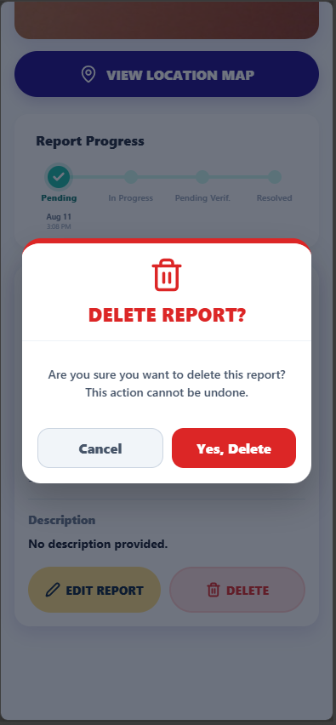  Account Active Status  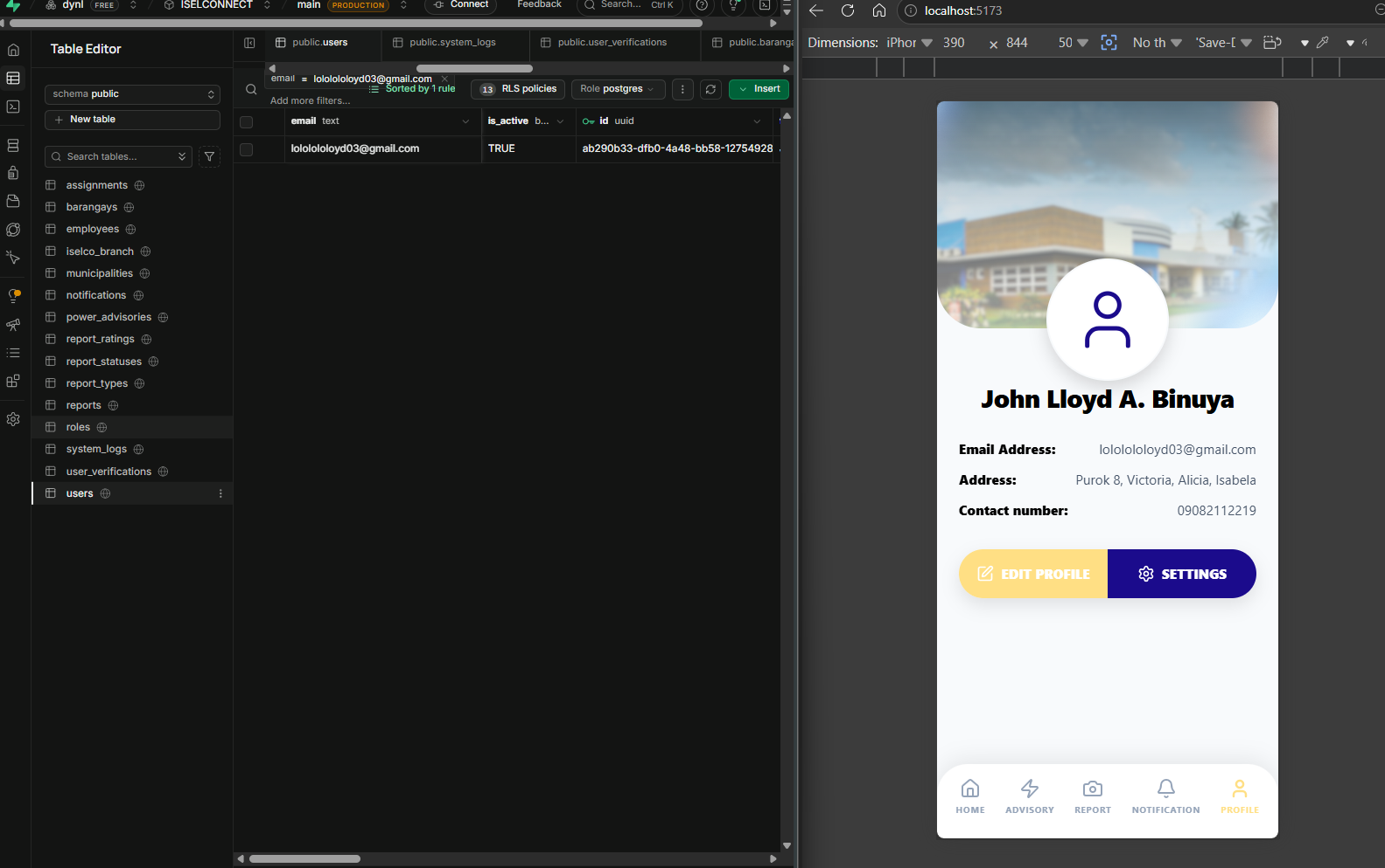  Valid ID User Authentication  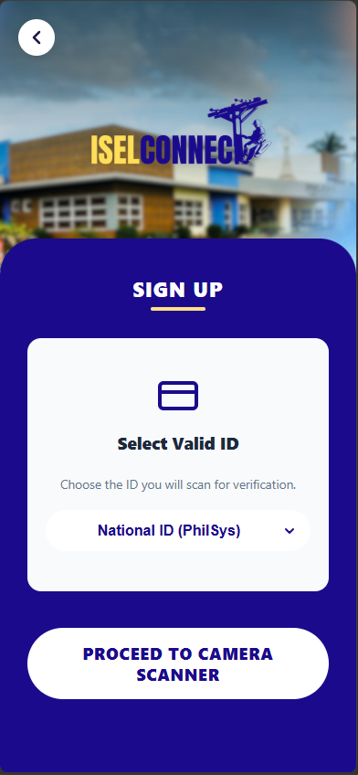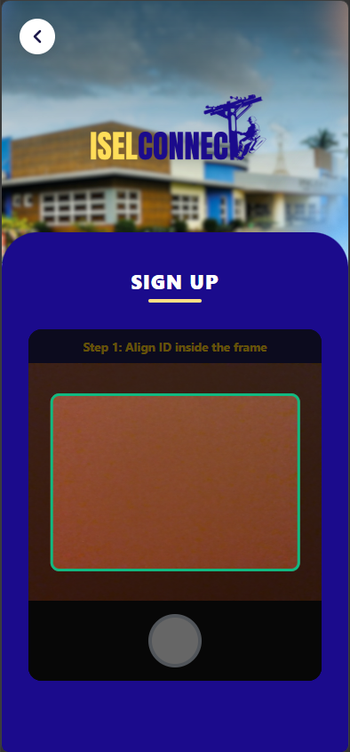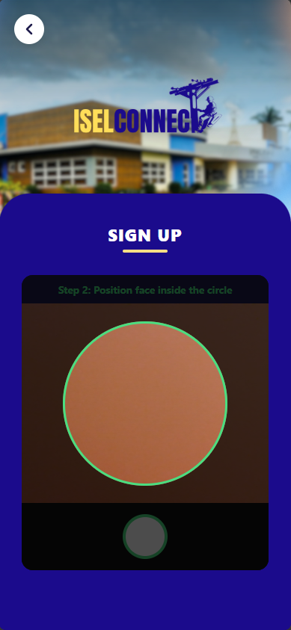  Forget Password  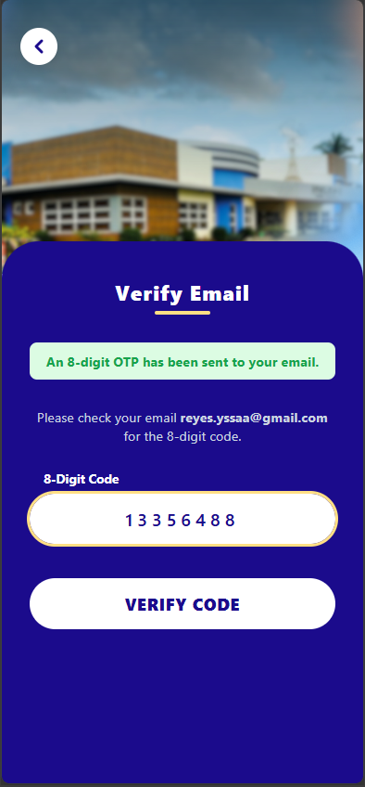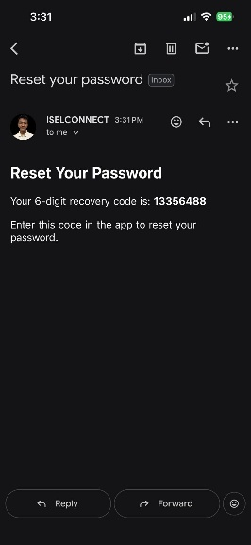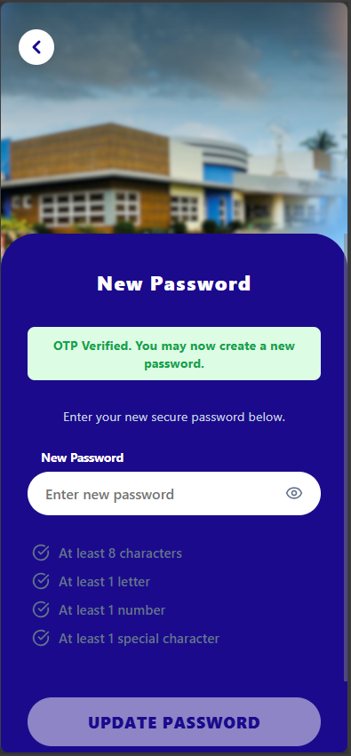  Account Banning  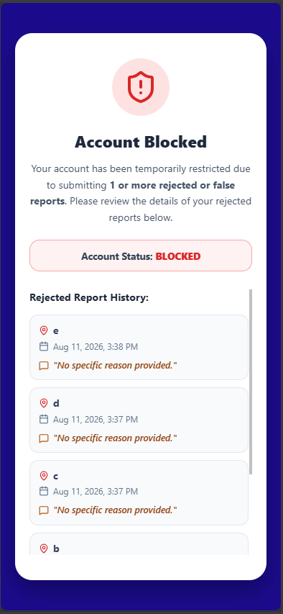 | Error Message: Internet Connection  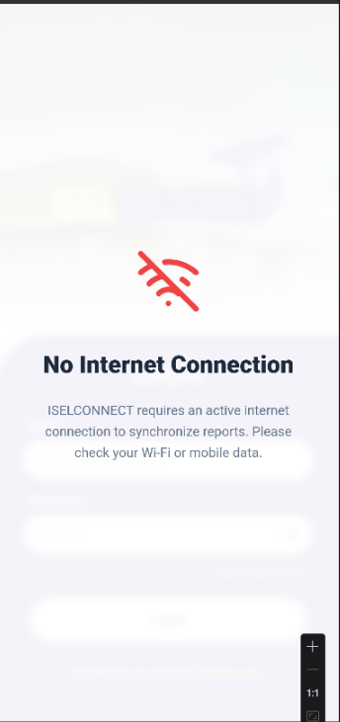  Survey / Ratings  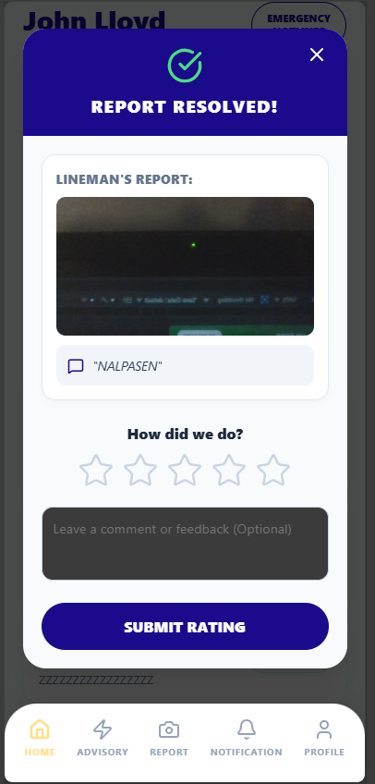  Report Verification  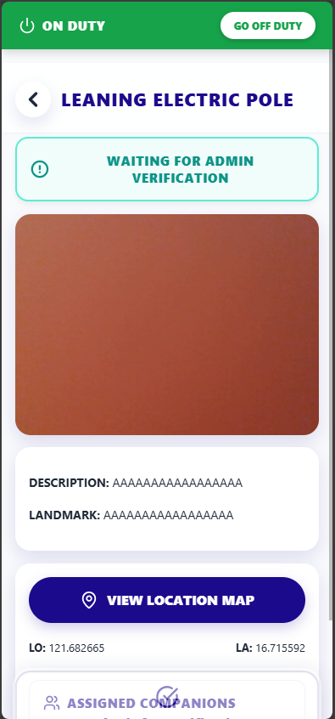  Report Progress Tracker  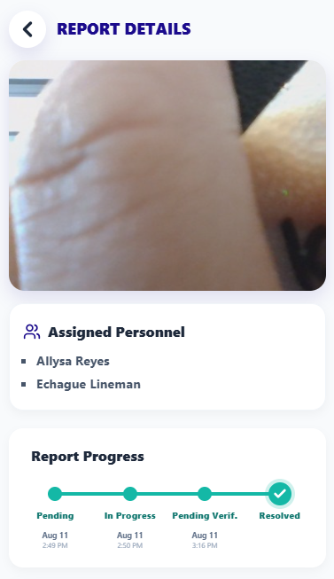
□ Source Code Screenshot

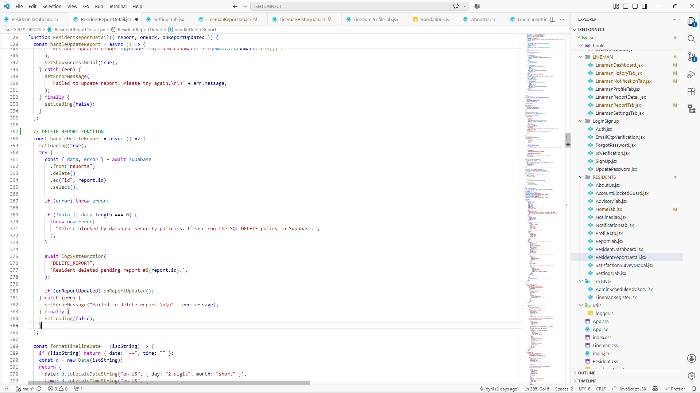

WEB
□ Screenshots Of Module

Map View

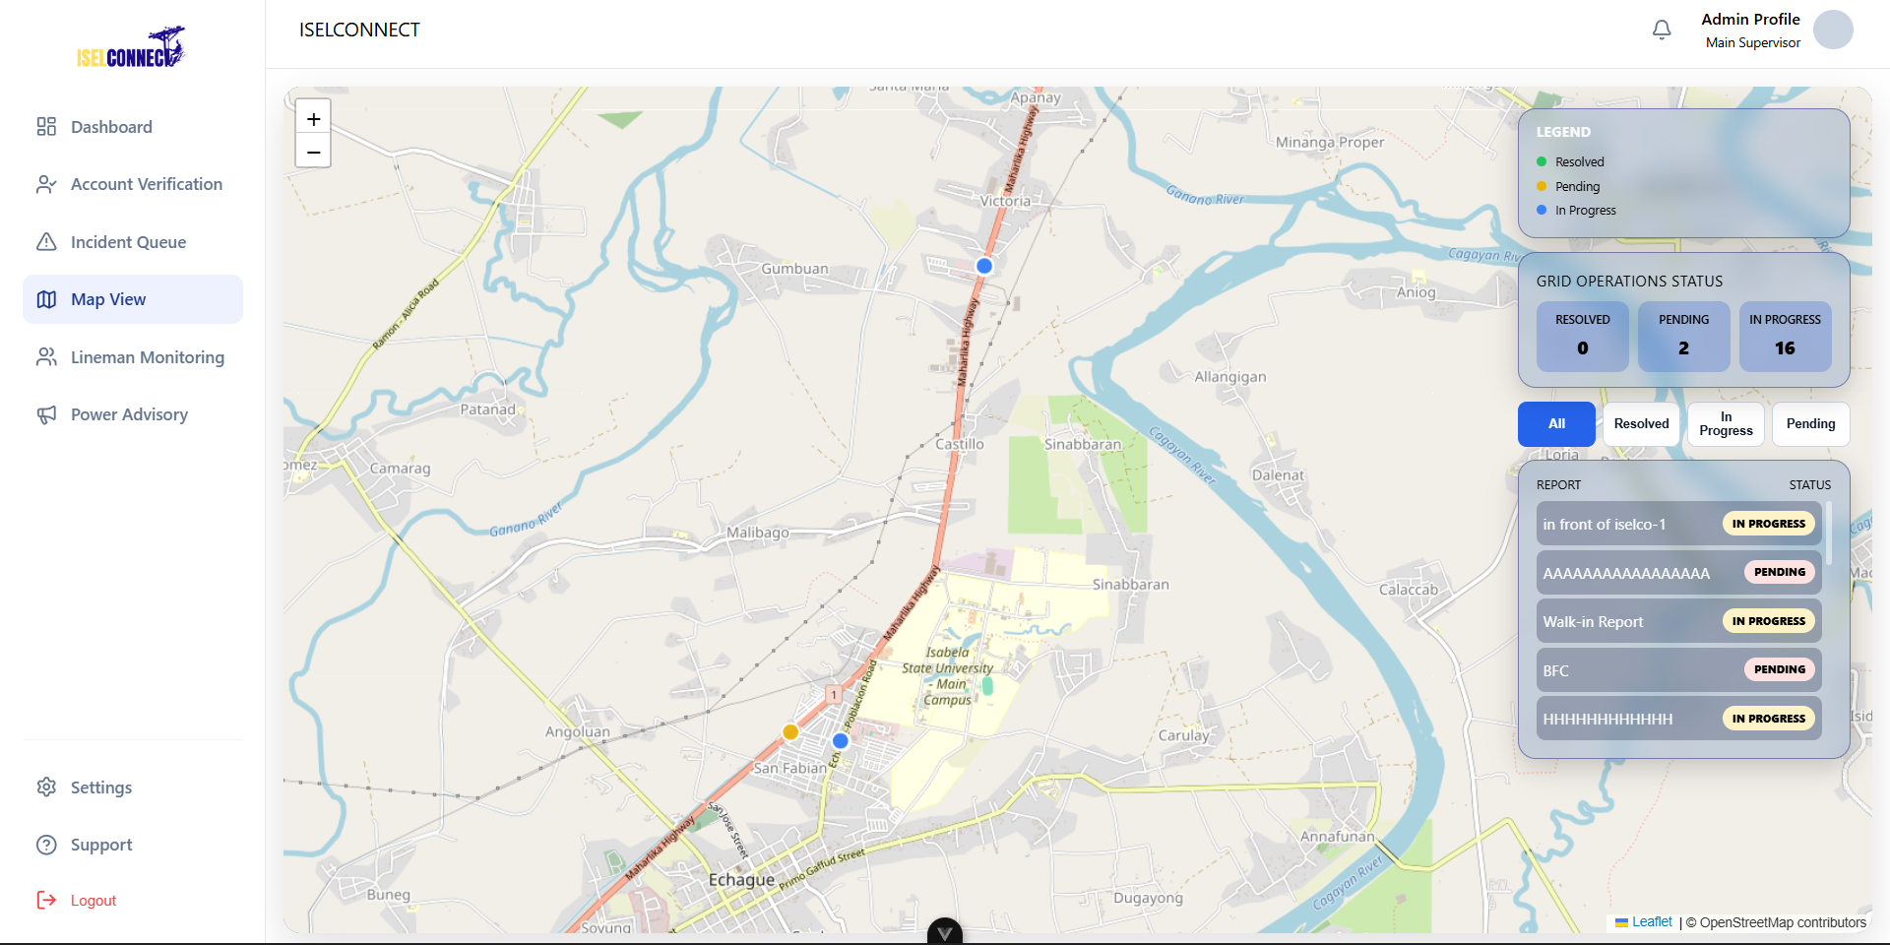
Lineman Monitoring
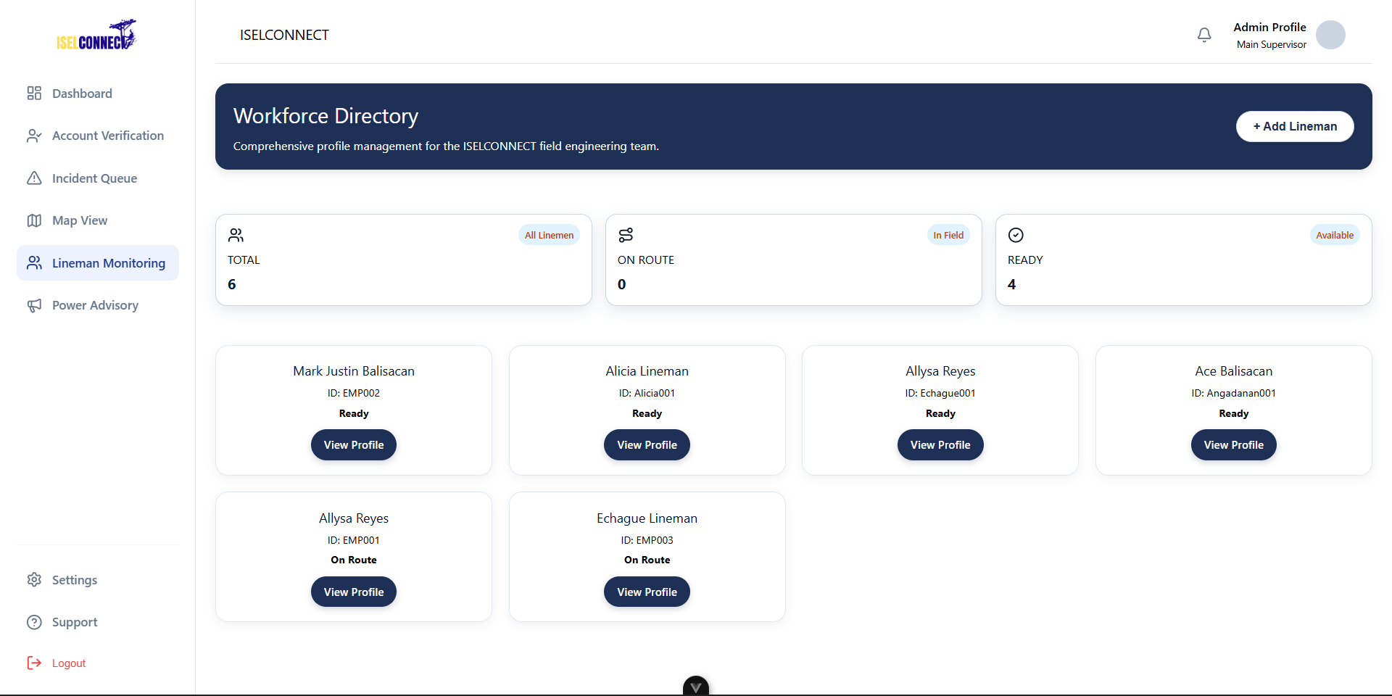

Power Advisory
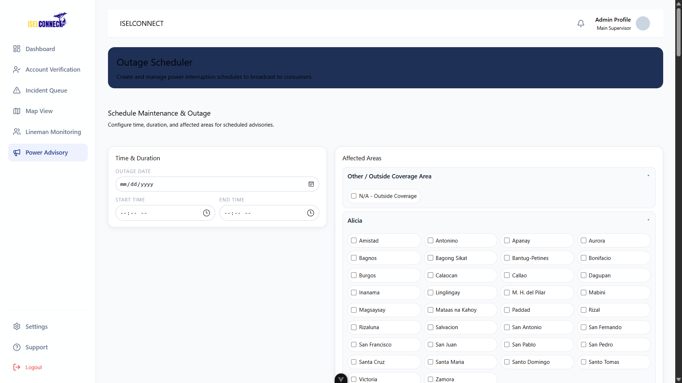

Analytics
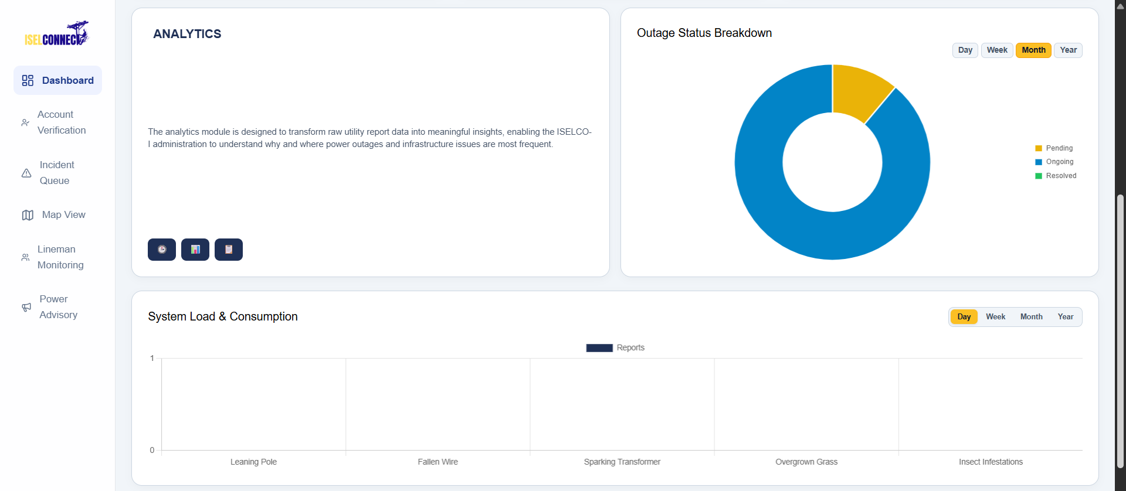
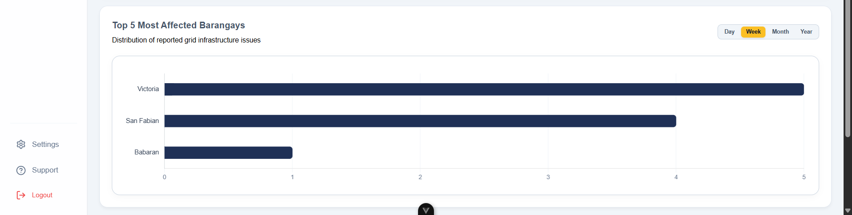
Branch Module
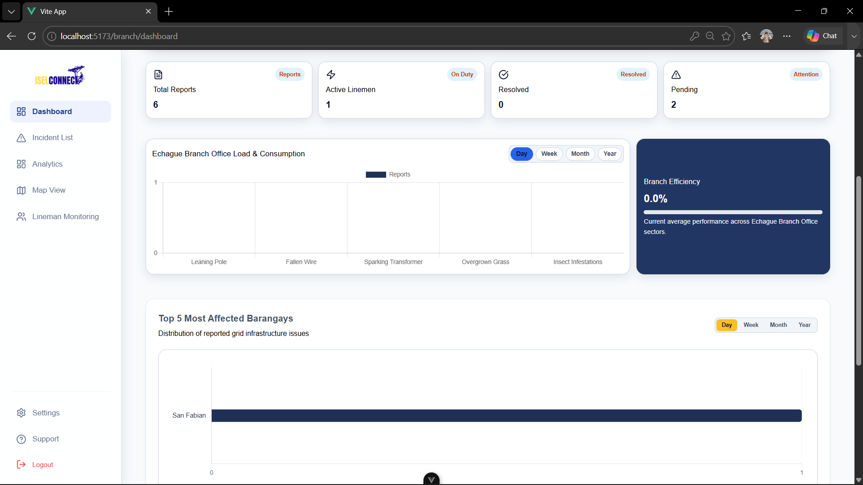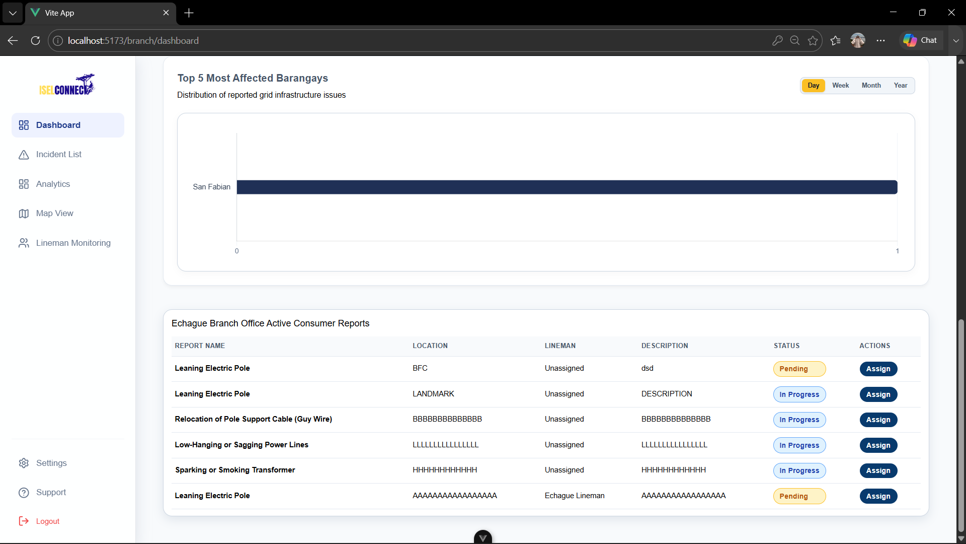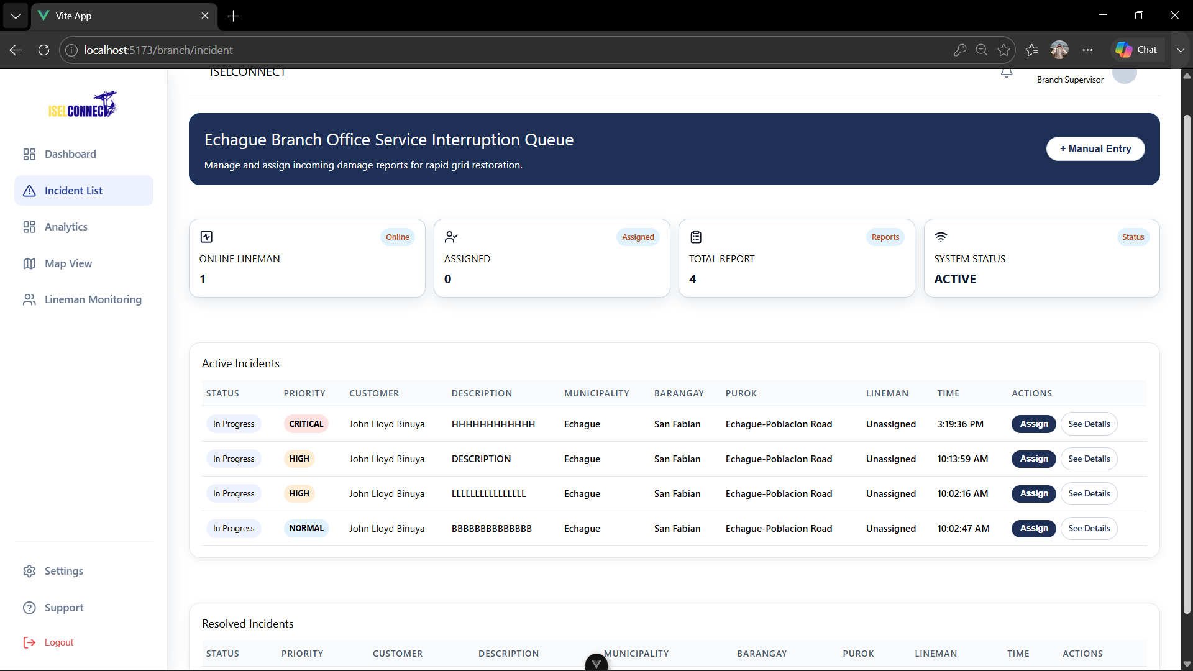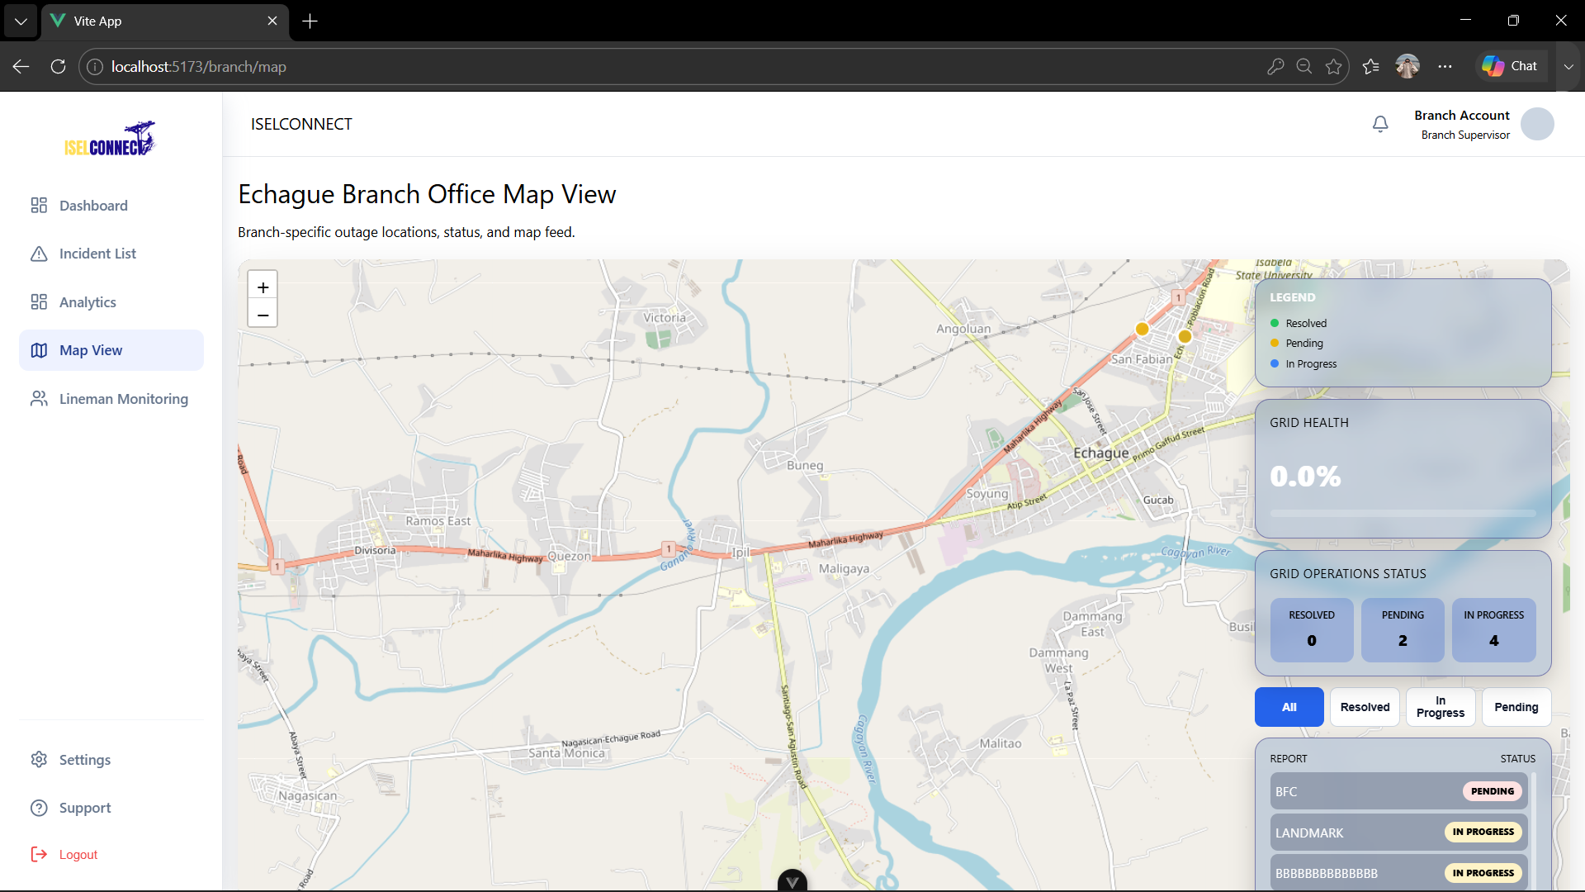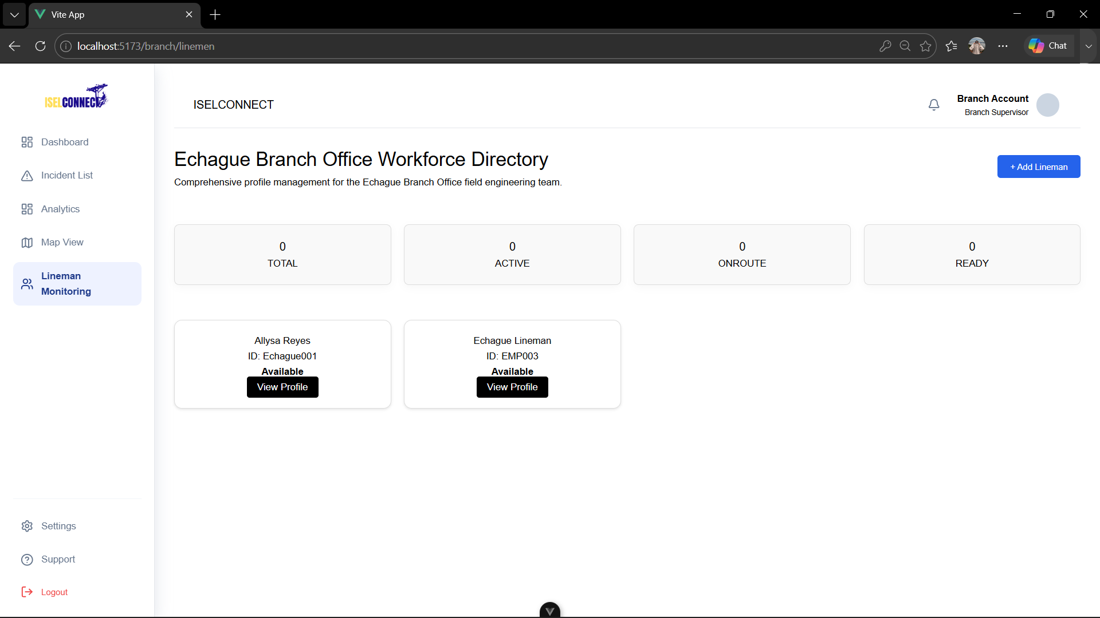

□ Source Code Screenshot
Map View
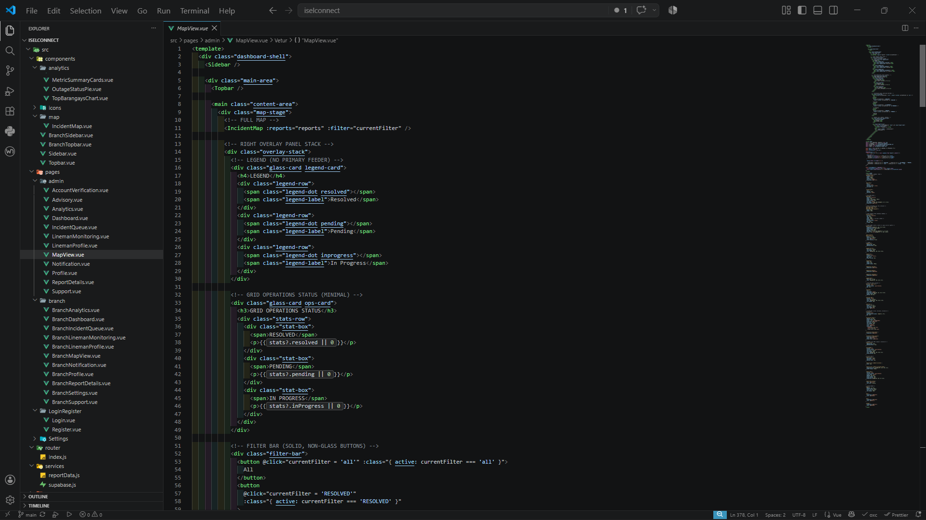
Lineman Monitoring
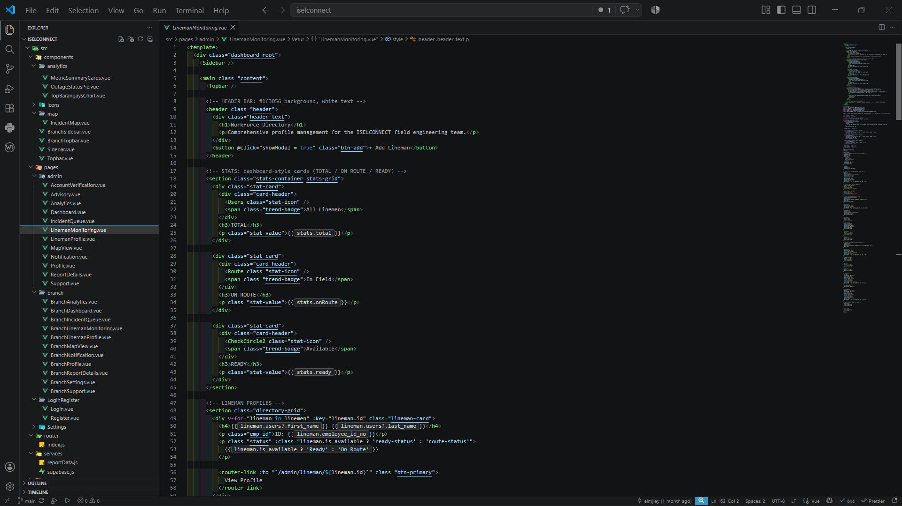

Power Advisory
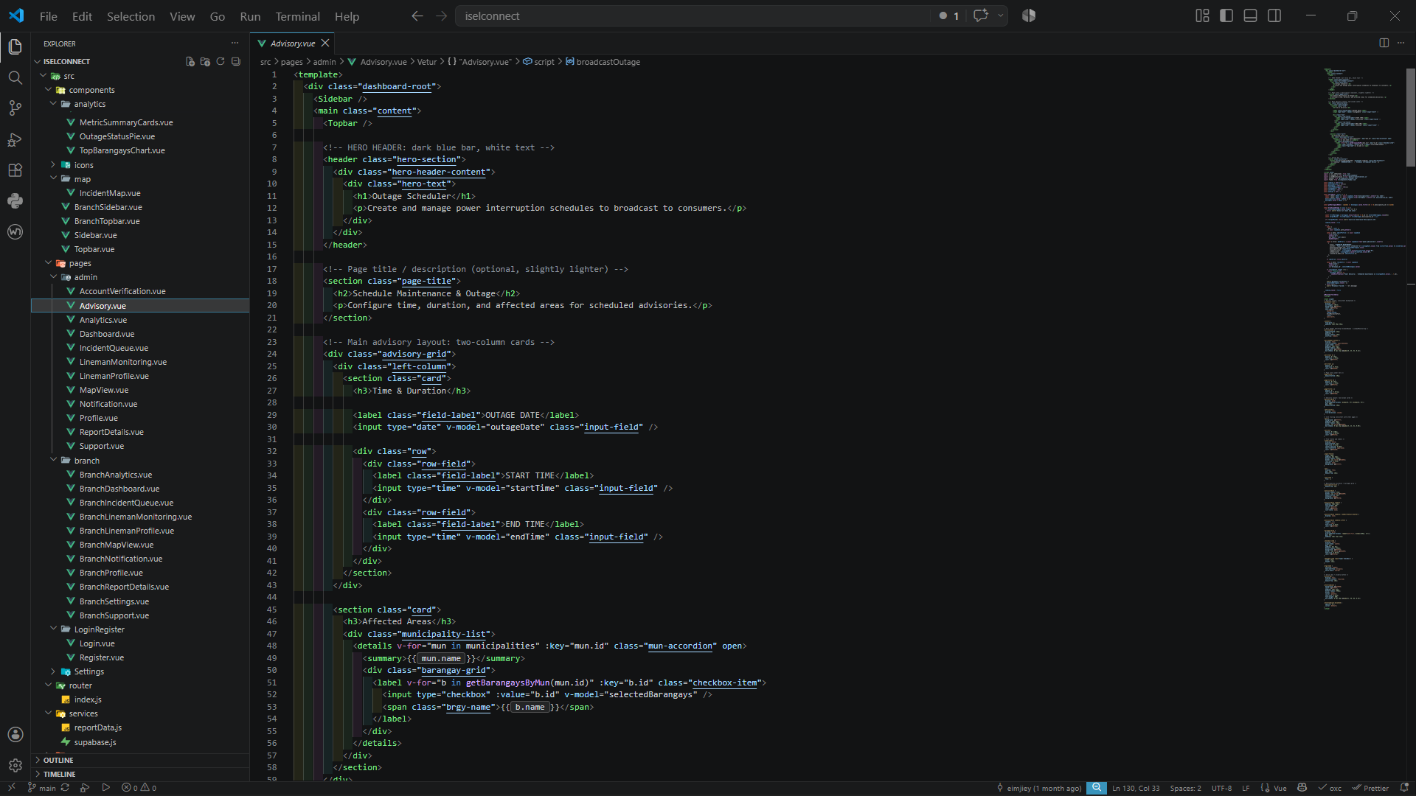
Analytics
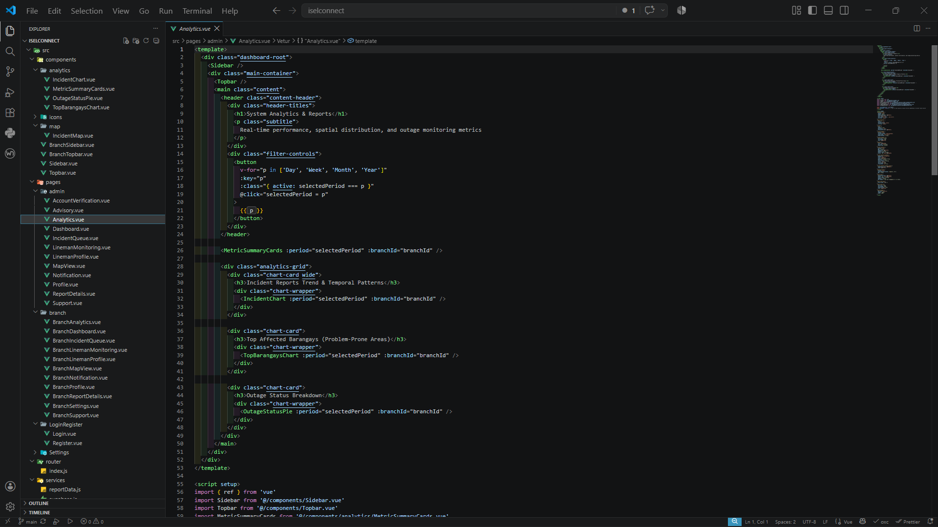
Branch Module
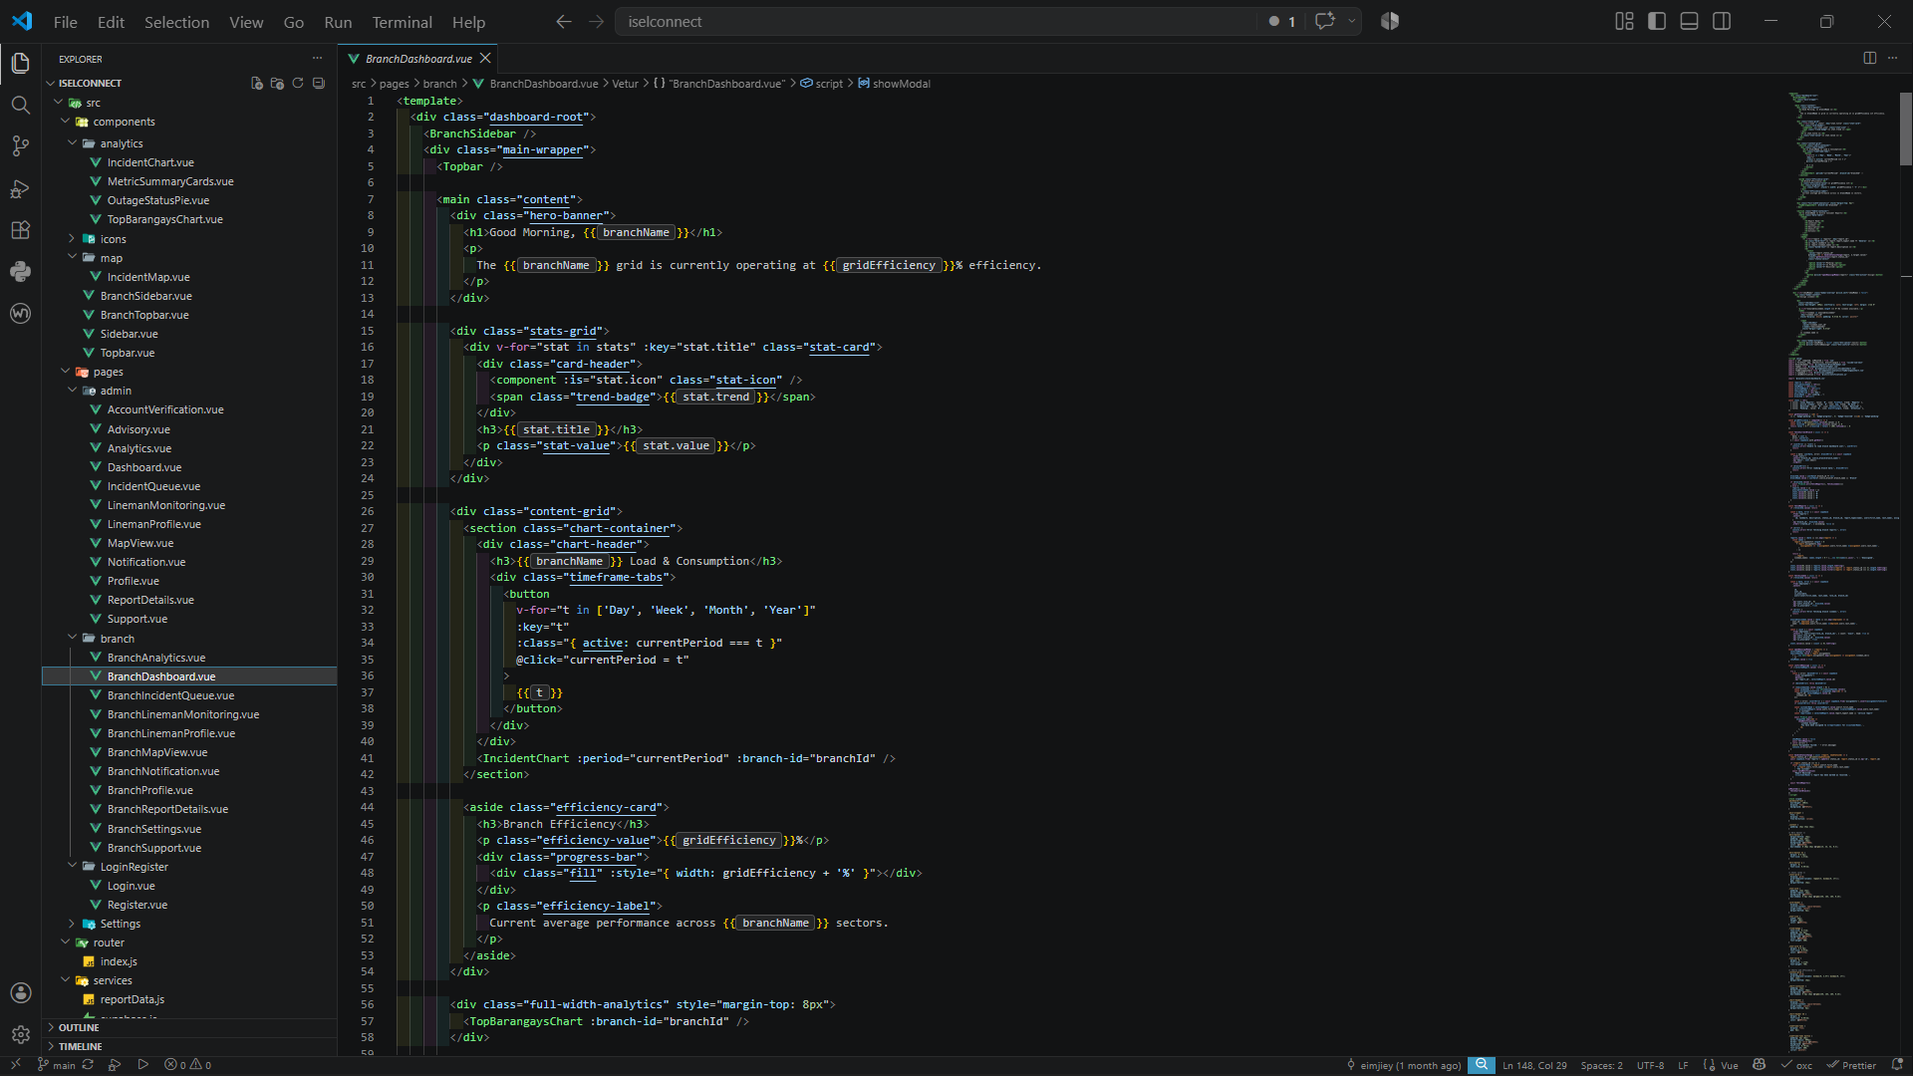
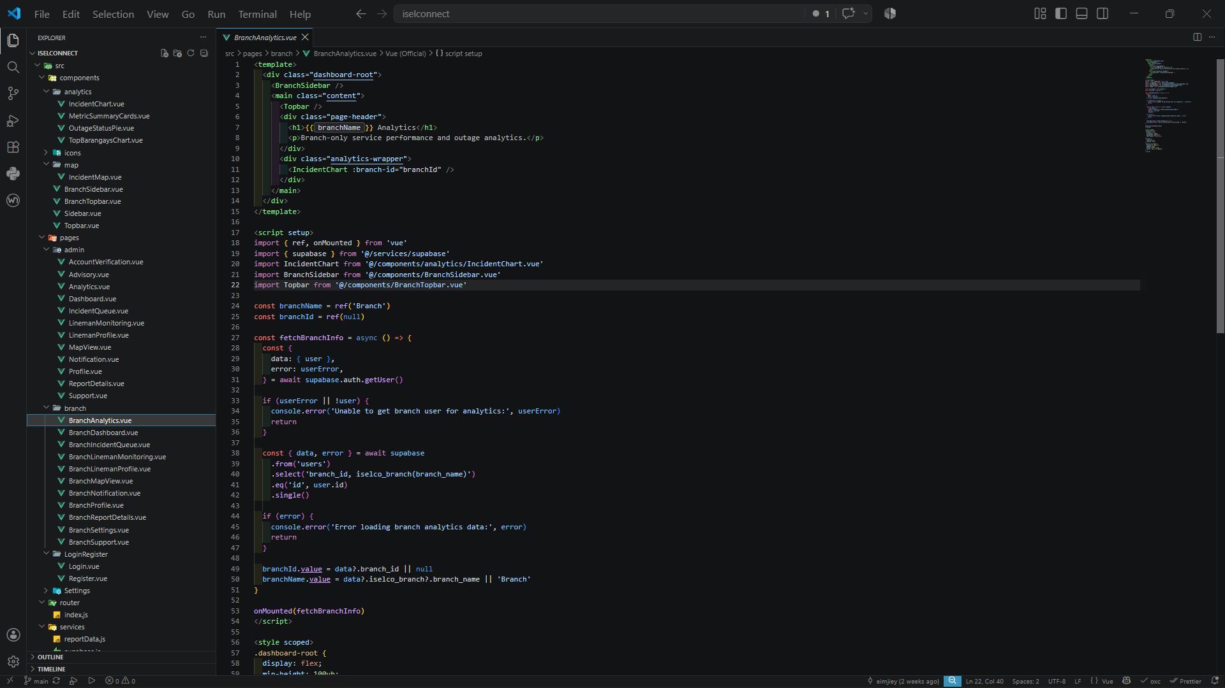
□ Demonstration Screenshot
Map View
Lineman Monitoring

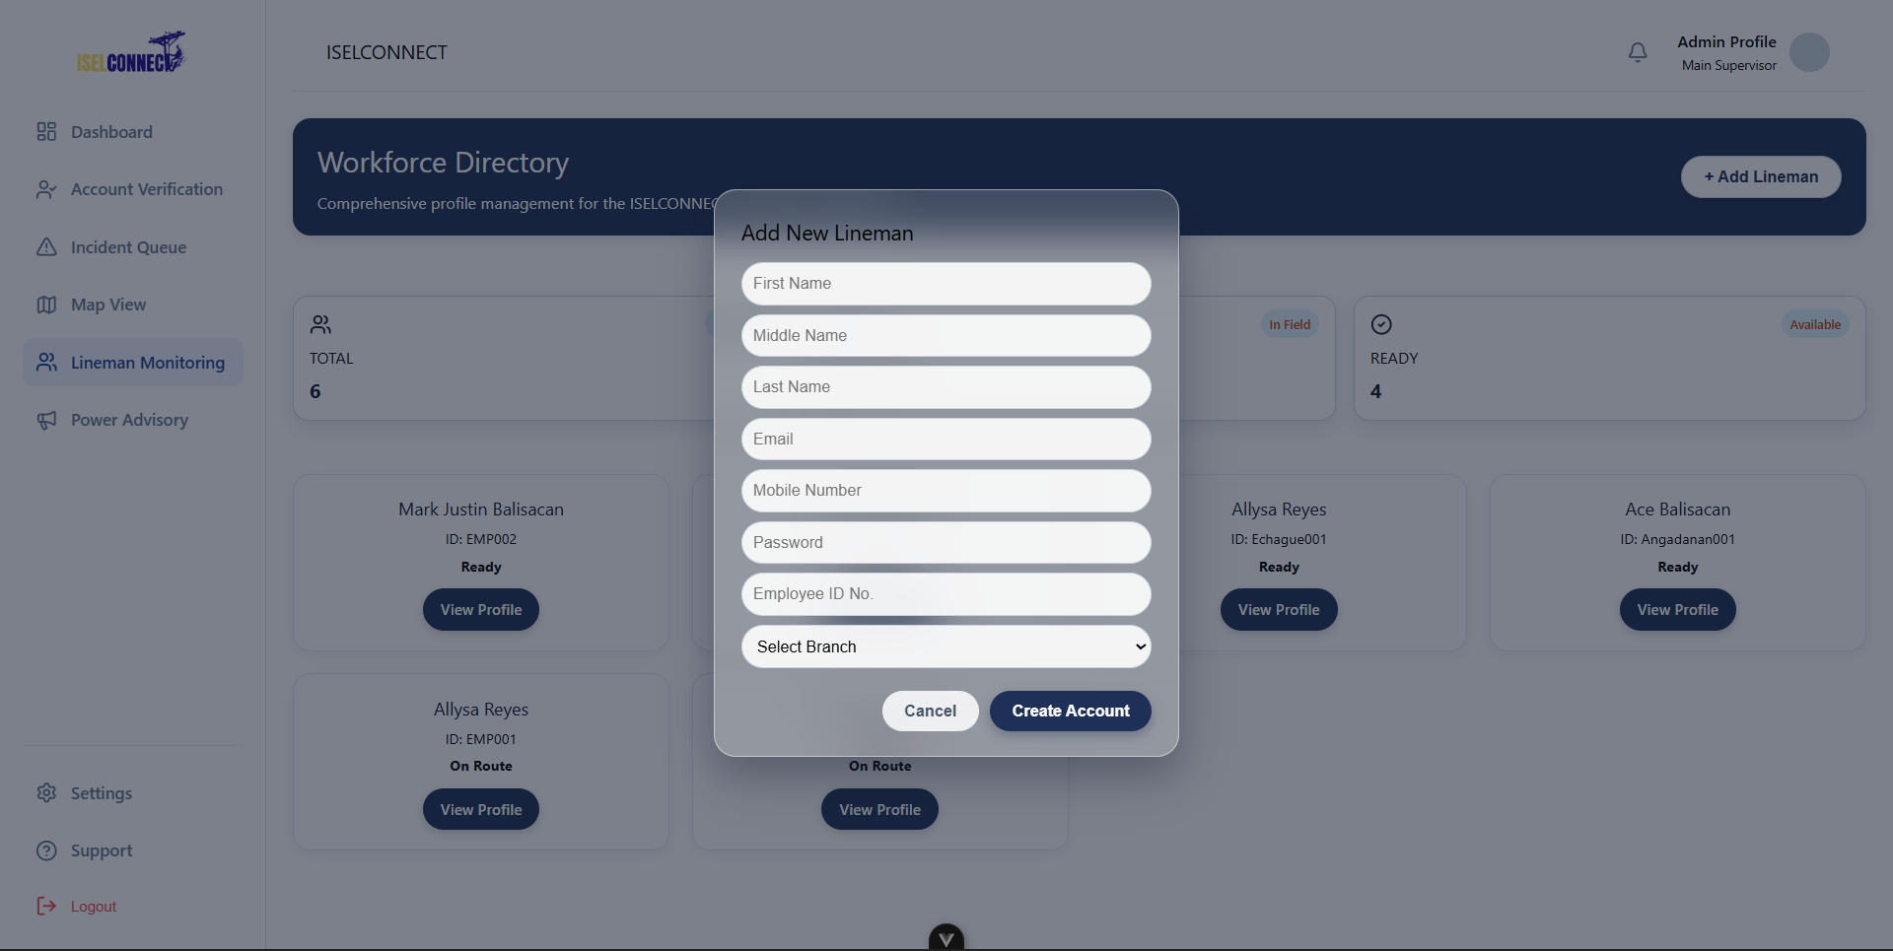

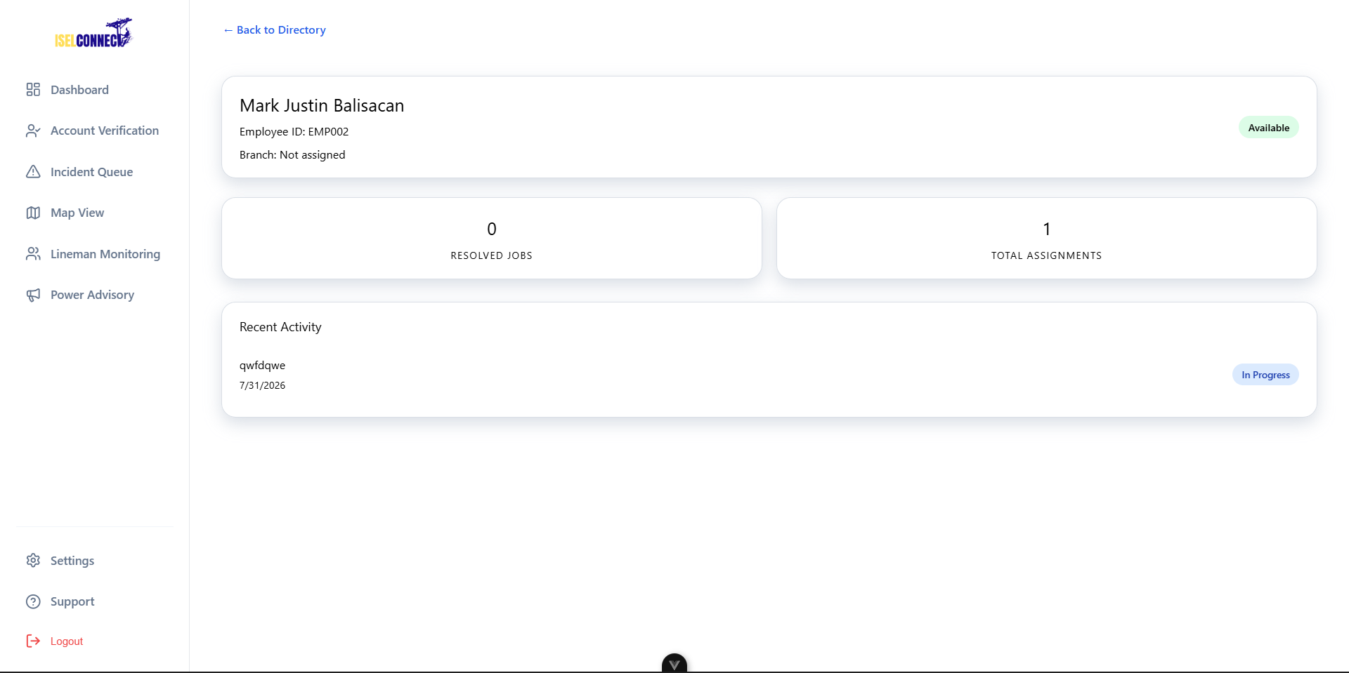

Power Advisory
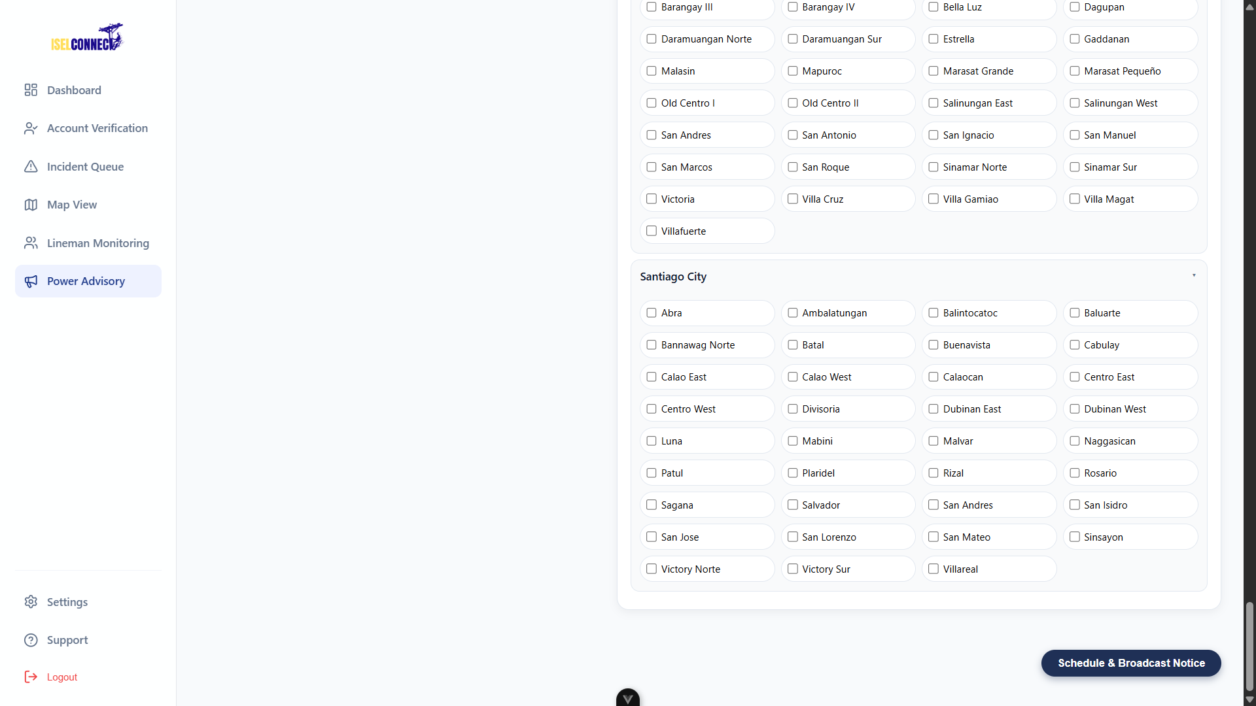

Analytics
Branch Module

ACTIVITY 3
AUTHENTICATION AND SECURITY IMPLEMENTATION

Purpose
To Implement User Authentication, Authorization, And Basic Security Controls.
Procedure
- Develop Login And Logout Functionalities.
- Implement User Role Management.
- Configure Access Permissions.
- Apply Password Protection Mechanisms.
- Test Authentication Processes.
- Complete Form 3.

FORM 3
AUTHENTICATION AND SECURITY IMPLEMENTATION REPORT

Directions
Indicate The Security Features Implemented in the System.

Security Feature | Implemented | Remarks
Login Authentication | ☑ | Secure user login
Logout Function | ☑ | Properly ends user session
Password Validation | ☑ | Validates password requirements
Role-Based Access Control | ☑ | Restricts access based on user role
Session Management | ☑ | Maintains secure user sessions
Input Validation | ☑ | Prevents invalid or unsafe inputs

Authentication Testing Results

Test Scenario | Result
Valid Login Credentials | Pass
Invalid Login Credentials | Pass
Unauthorized Access Attempt | Pass
Session Timeout Test | Pass

Required Evidence

MOBILE
□ Login Screen Screenshot  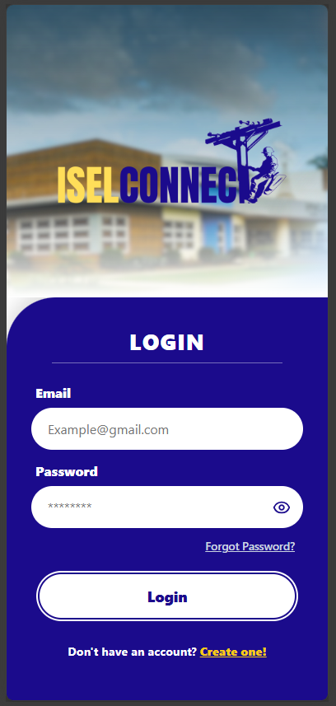 | □ User Role Management Screenshot  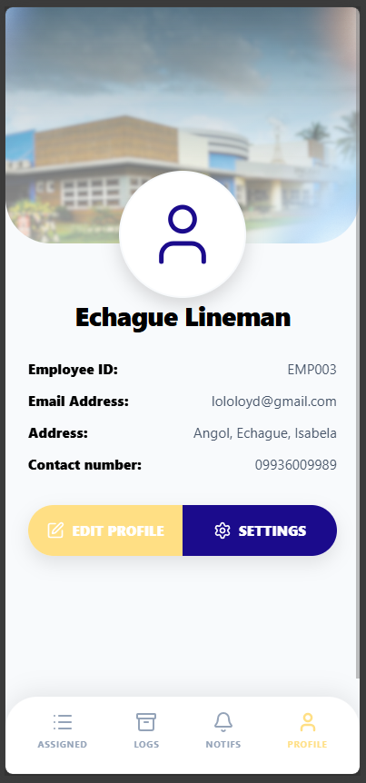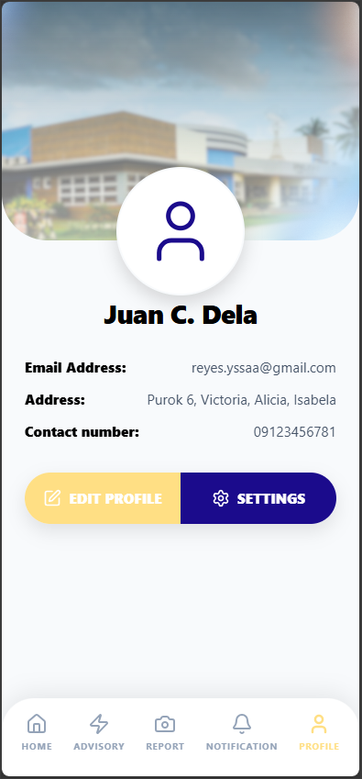

WEB
□ Login Screen Screenshot
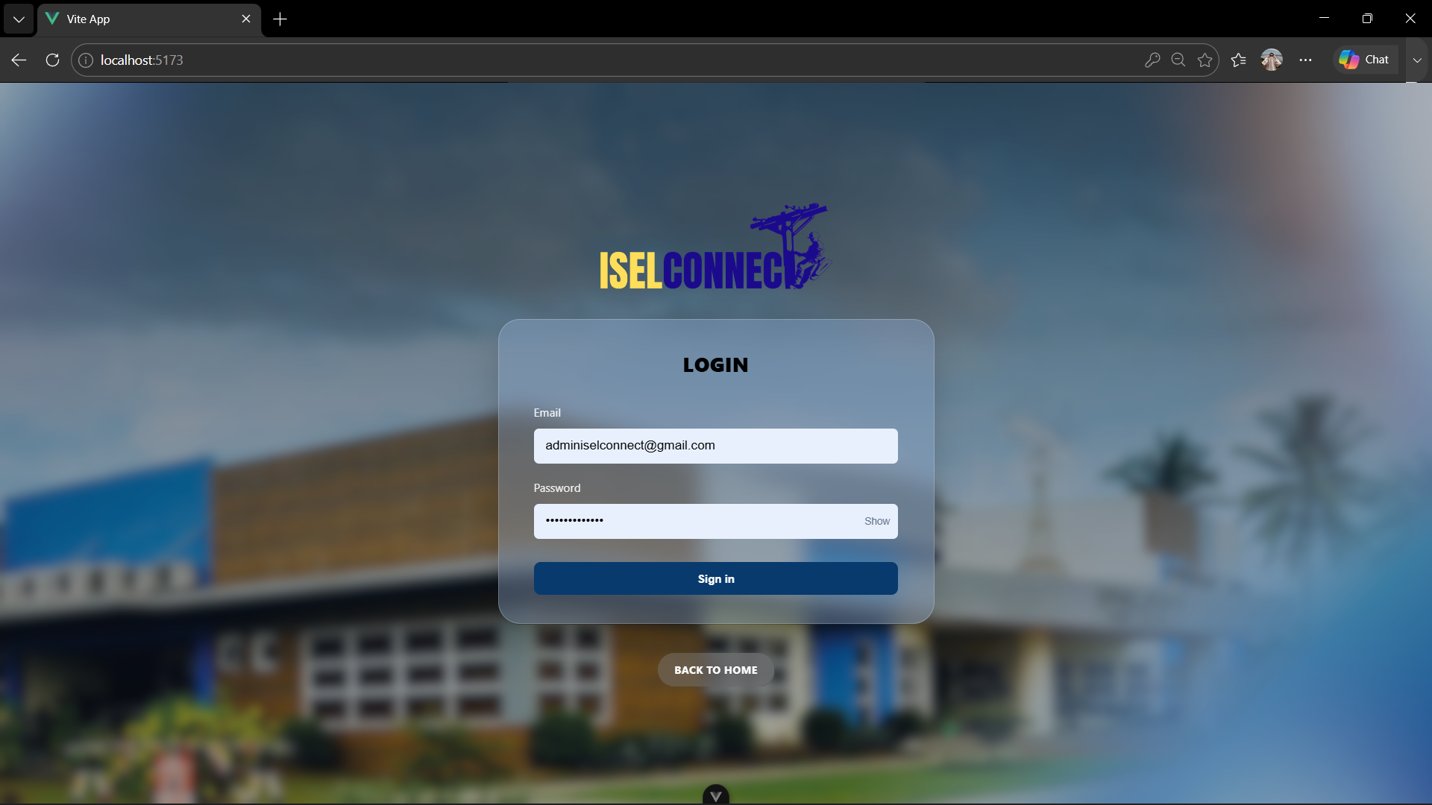

□ User Role Management Screenshot

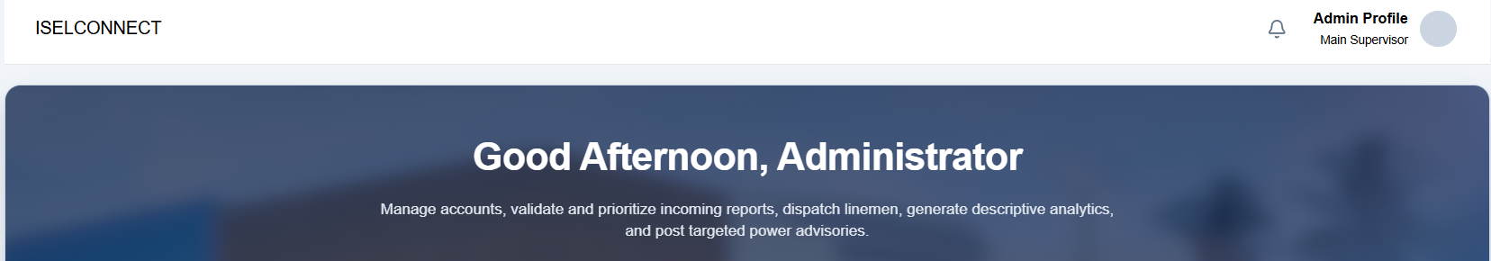

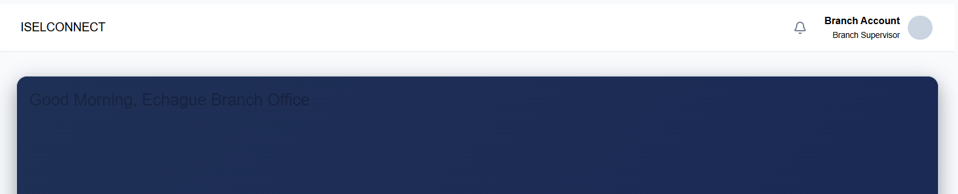

ACTIVITY 4
FRONT-END AND BACK-END INTEGRATION

Purpose
To Establish Communication Between User Interfaces, Application Logic, And Database Components.
Procedure
- Connect Front-End Forms to Back-End Services.
- Configure Database Transactions.
- Verify Data Flow Between Components.
- Test Create, Read, Update, And Delete (CRUD) Operations.
- Complete Form 4.

FORM 4
SYSTEM INTEGRATION REPORT

Directions
Document The Integrated Components of the System.
Component Integrated | Status | Remarks
User Interface ↔ Back-End | Integrated | The web and mobile interfaces successfully communicate with Supabase services.
Back-End ↔ Database | Integrated | Supabase successfully stores and retrieves data from the PostgreSQL database.
Authentication ↔ Database | Integrated | User authentication and account data are properly managed through Supabase.
Reporting ↔ Database | Integrated | Reports are successfully stored and retrieved from the database.

CRUD Functionality Verification
Function | Result
Create | Pass
Read | Pass
Update | Pass
Delete | Pass

Required Evidence

MOBILE
□ Data Entry Demonstration

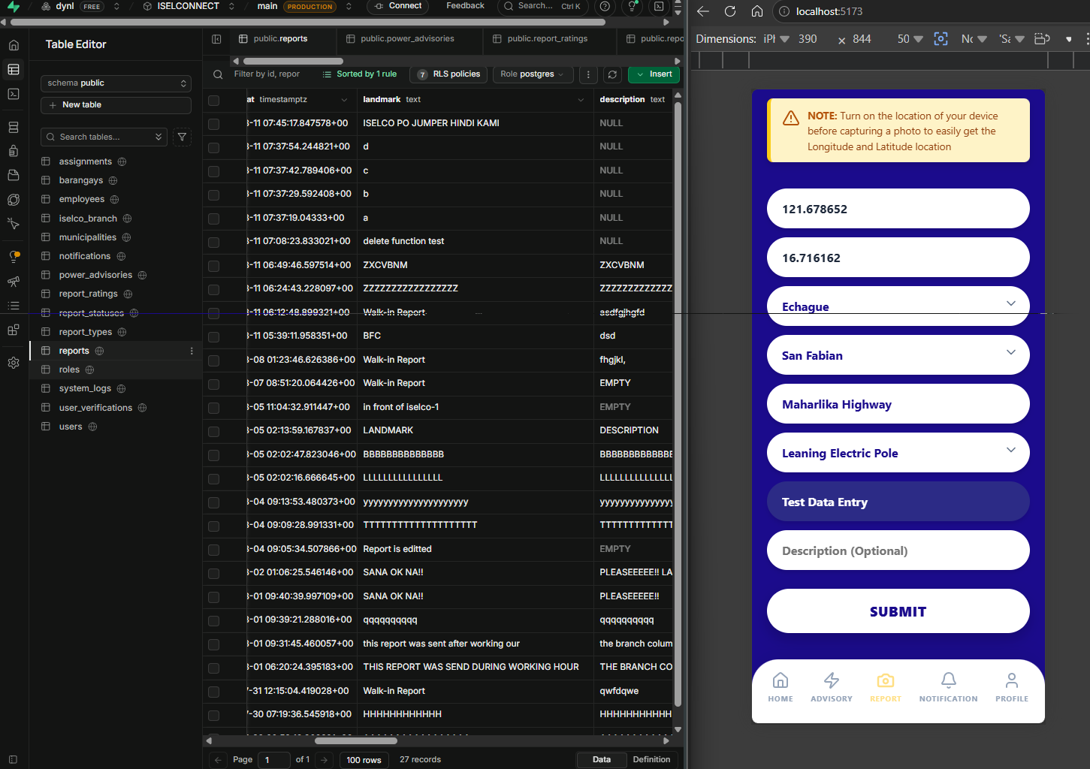

□ Database Update Screenshot

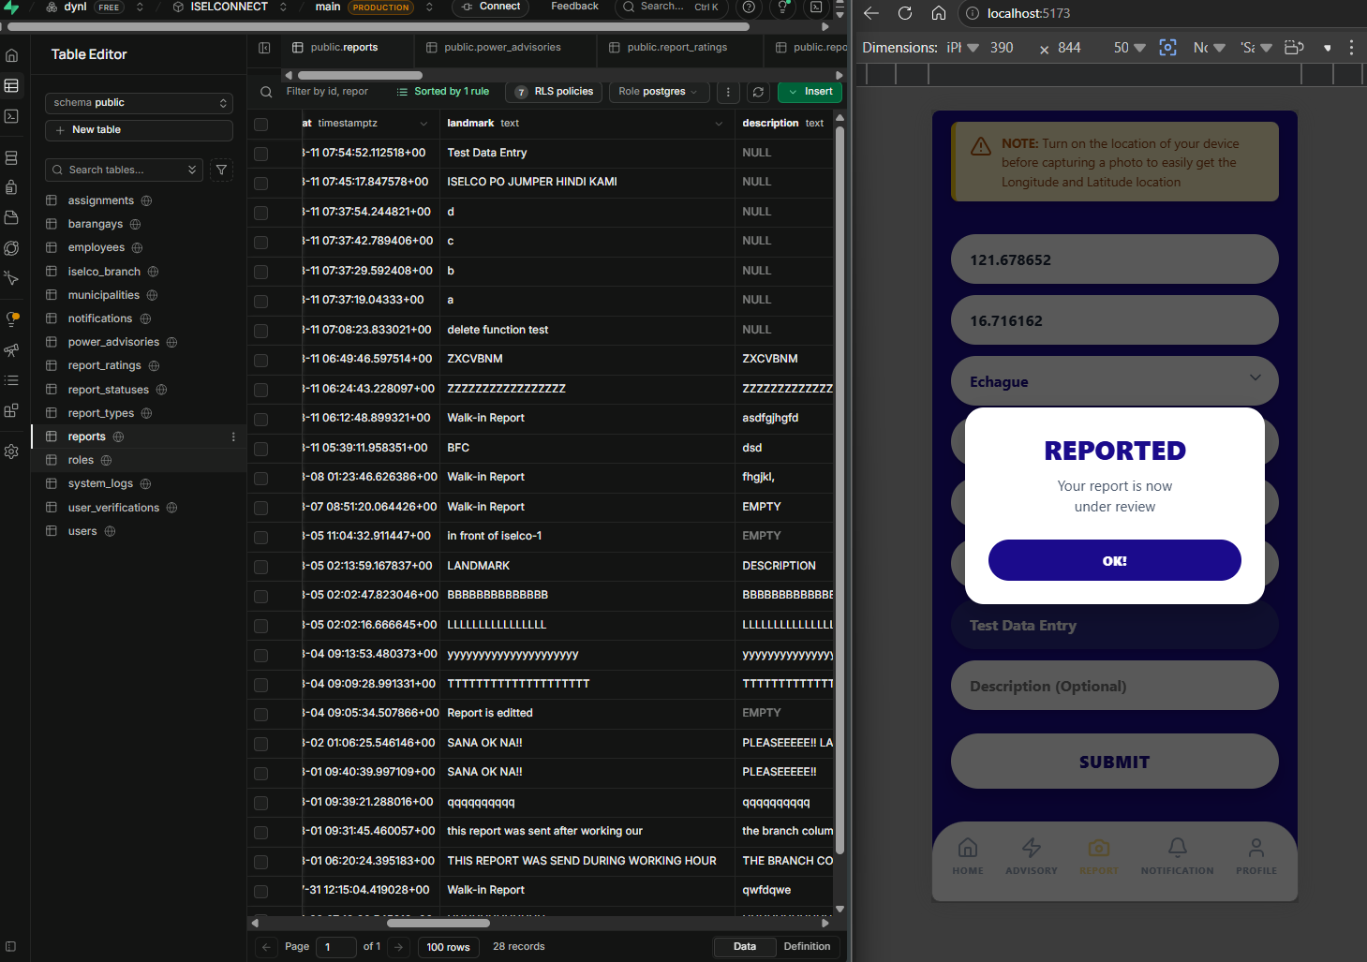

WEB
□ Data Entry Demonstration
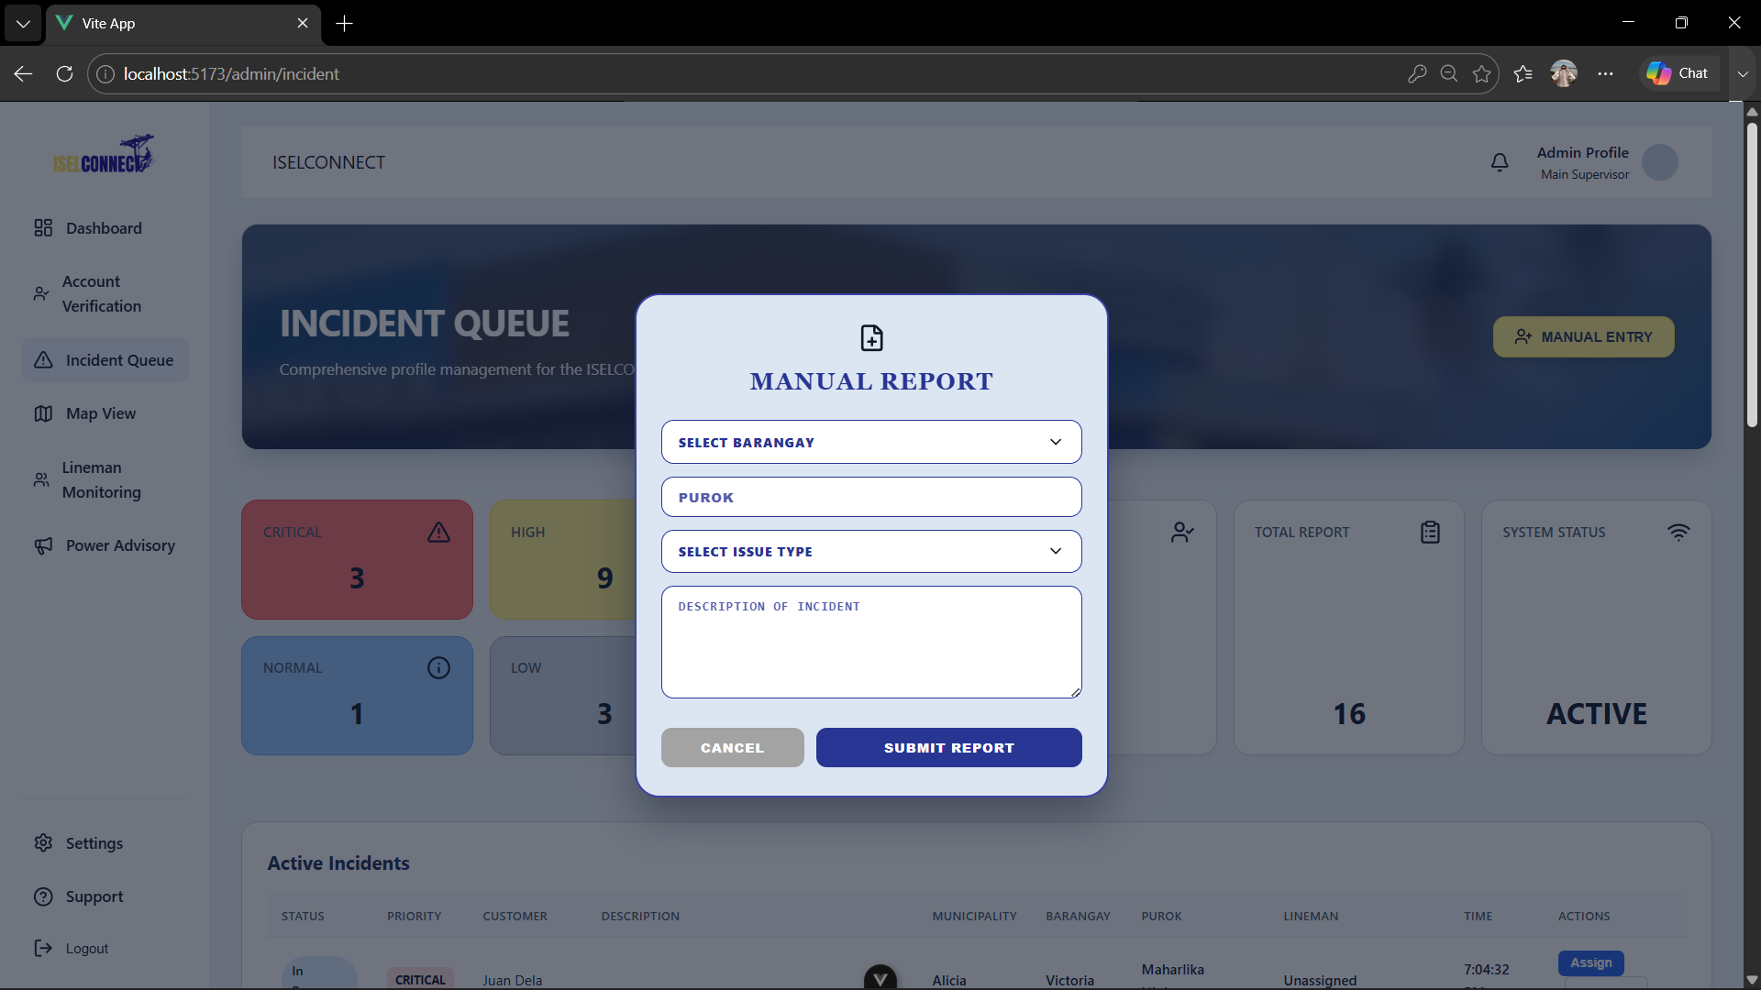
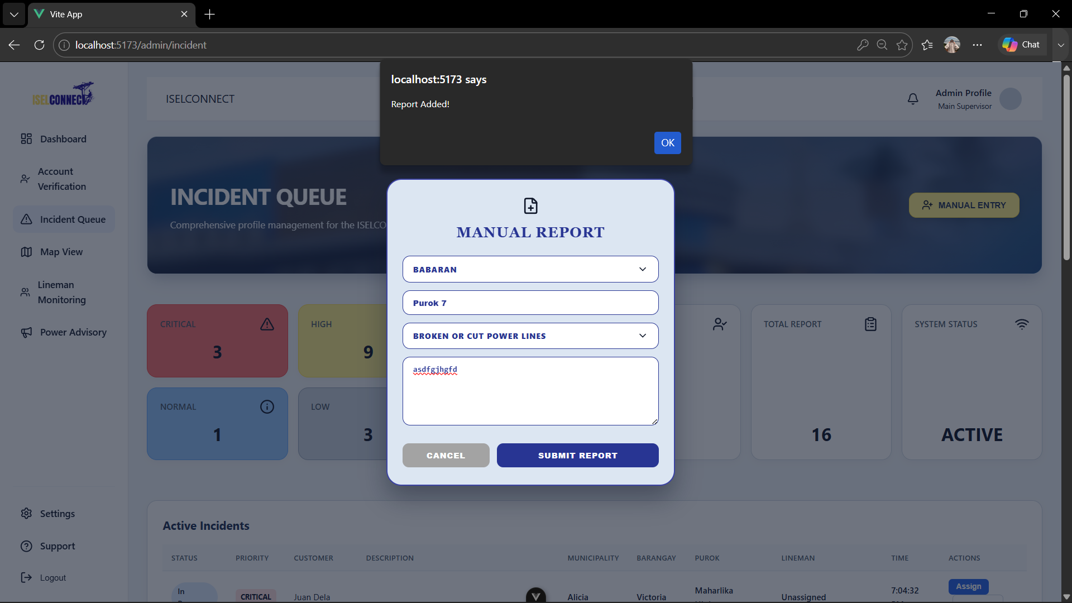

□ Database Update Screenshot

ACTIVITY 5
INTEGRATION TESTING

Purpose
To Verify That Integrated Modules Work Together Correctly.
Procedure
- Execute End-To-End System Transactions.
- Observe System Responses.
- Record Issues Encountered.
- Implement Corrective Actions.
- Complete Form 5.

FORM 5
INTEGRATION TESTING CHECKLIST

Directions
Test Integrated Modules and Record Results.
Test Case | Expected Result | Actual Result | Status
Resident deletes pending report | Pending report is successfully deleted. | Report was successfully deleted. | Pass
User accesses app without internet | System displays an internet connection error message. | Error message was displayed. | Pass
Admin views account status | Admin can view whether an account is active. | Account status was displayed correctly. | Pass

Issues Identified
Issue | Severity | Action Taken
Resident report deletion was initially limited to pending reports. | Low | Verified and implemented the restriction so only pending reports can be deleted.
No-internet access needed a clear user notification. | Medium | Added an internet connection error message when the application detects no network access.
Admin needed visibility of user account status. | Low | Implemented and verified the account active-status display in the admin interface.

Tester Information
Conducted By: Allysa B. Reyes

Date: August 12, 2026

ACTIVITY 6
REPOSITORY UPDATE REPORT

Purpose
To Document All Development Activities Uploaded to the Repository.
Procedure
- Commit All Completed Code.
- Update Documentation.
- Record Development Milestones.
- Complete Form 6.

FORM 6
REPOSITORY UPDATE REPORT

Repository URL: https://github.com/ISELCONNECT-ORG/iselconnect_mobile

Commits Made This Week
Commit Description | Date
Feat: report's delete function added | August 9, 2026
Fix: delete function and notifier fixed | August 11, 2026
feat | style: duty timestamp and report list UI | August 11, 2026

Repository URL: https://github.com/ISELCONNECT-ORG/iselconnect_web

Commits Made This Week
Commit Description | Date
Style.ManualEntry | August 8, 2026

Repository Evidence

MOBILE

□ Updated Source Code  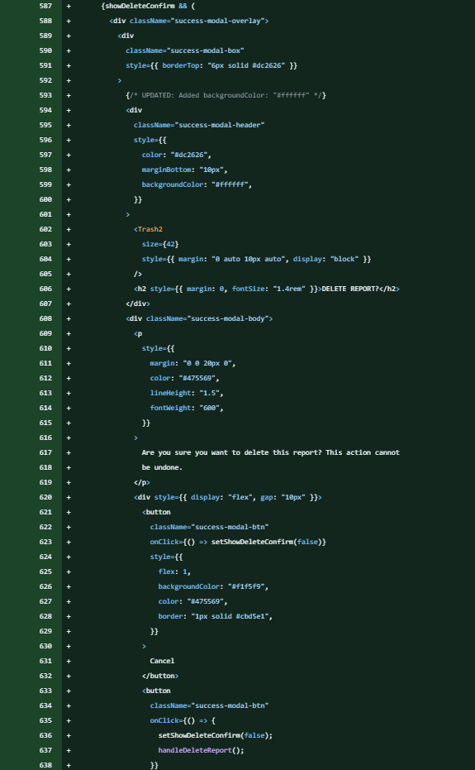 | □ Commit History Screenshot  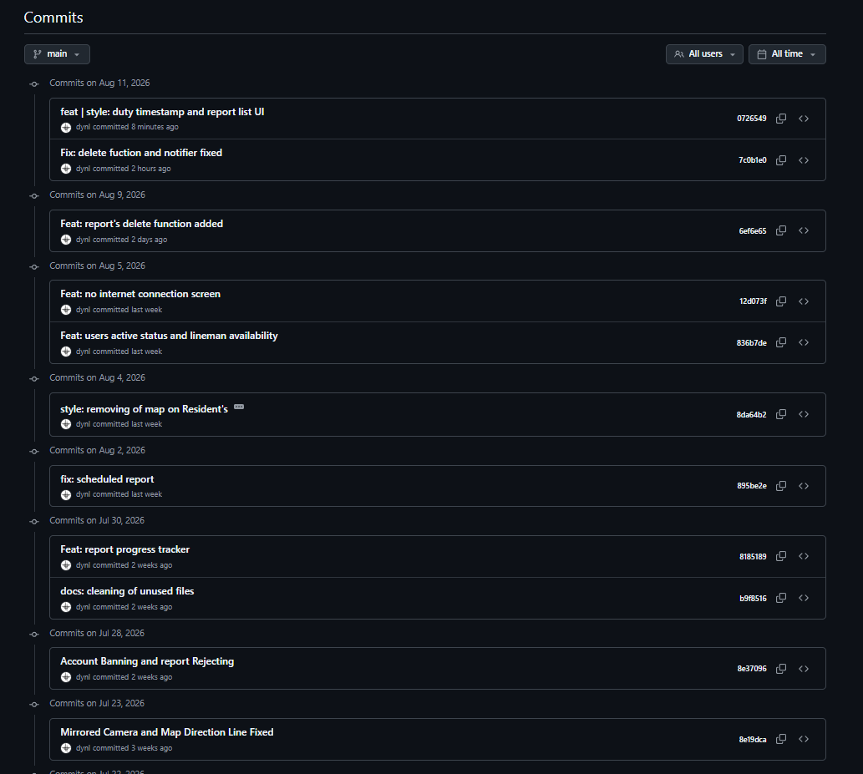
□ Team Contribution Screenshot

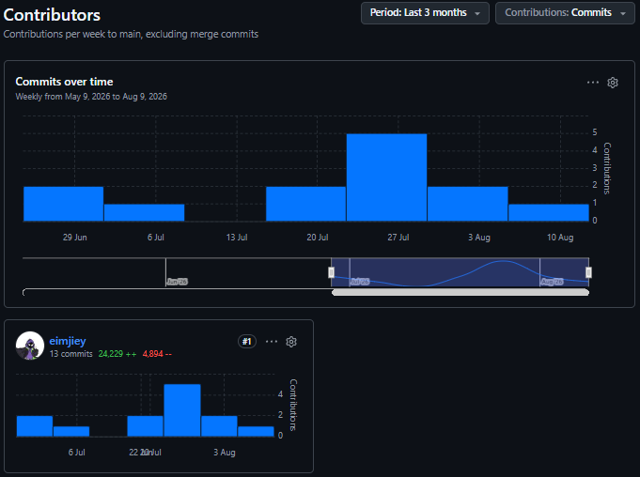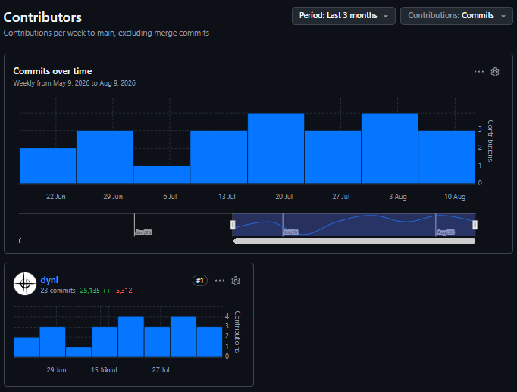

WEB

□ Updated Source

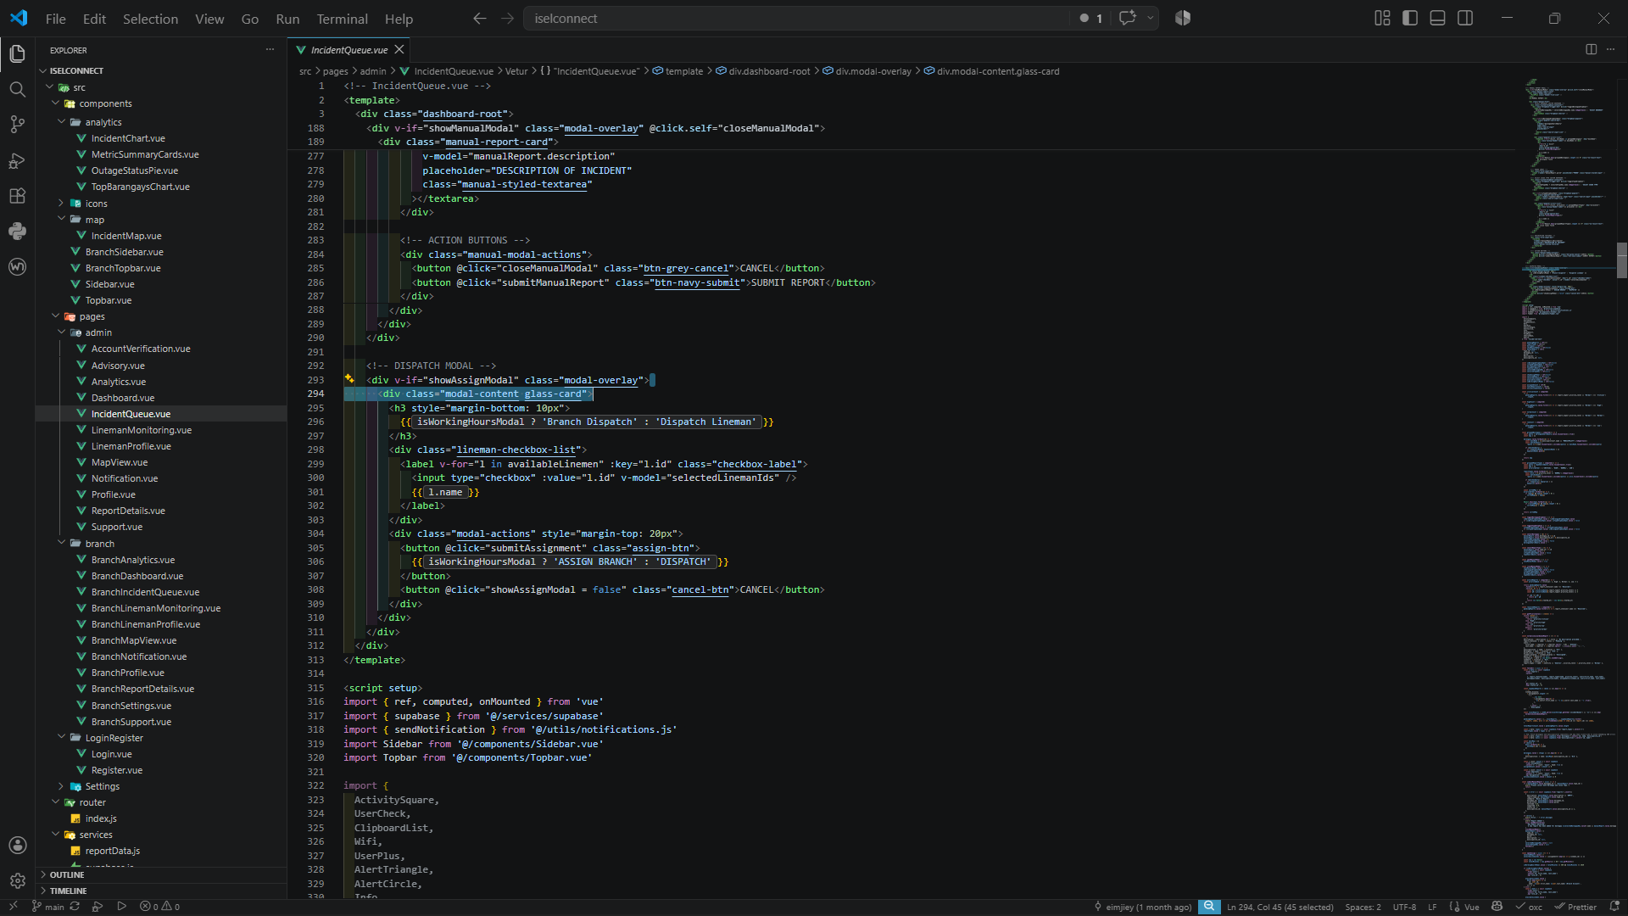
□ Commit History Screenshot

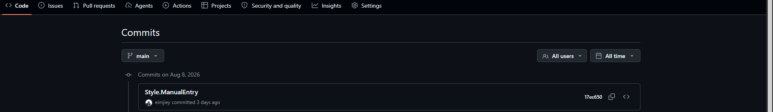

ACTIVITY 7
PROGRESS REPORT NO. 2

Purpose
To summarize development accomplishments and evaluate readiness for system integration and alpha version preparation.
Procedure
- Review All Completed Activities.
- Summarize Development Accomplishments.
- Identify Issues Encountered.
- Describe Corrective Actions Taken.
- Identify Week 5 Targets.
- Complete Form 7.

FORM 7
PROGRESS REPORT NO. 2

Project Information
Project Title: ISELCONNECT: A Power Outage and Visual Maintenance Report Management System

Date Submitted: August 12, 2026

Accomplishments This Week
Activity | Status
Advanced Module Development | In Progress
Authentication Implementation | Completed
Front-End And Back-End Integration | Completed
Integration Testing | In Progress

Major Accomplishments
- Completed remaining system functions and modules.
- Implemented error handling.
- Verified that tested functions are working as expected.

Challenges Encountered
- Some functions required additional validation during testing.
- Internet connectivity affected system accessibility during testing.

Corrective Actions Taken
- Verified and improved account status monitoring.

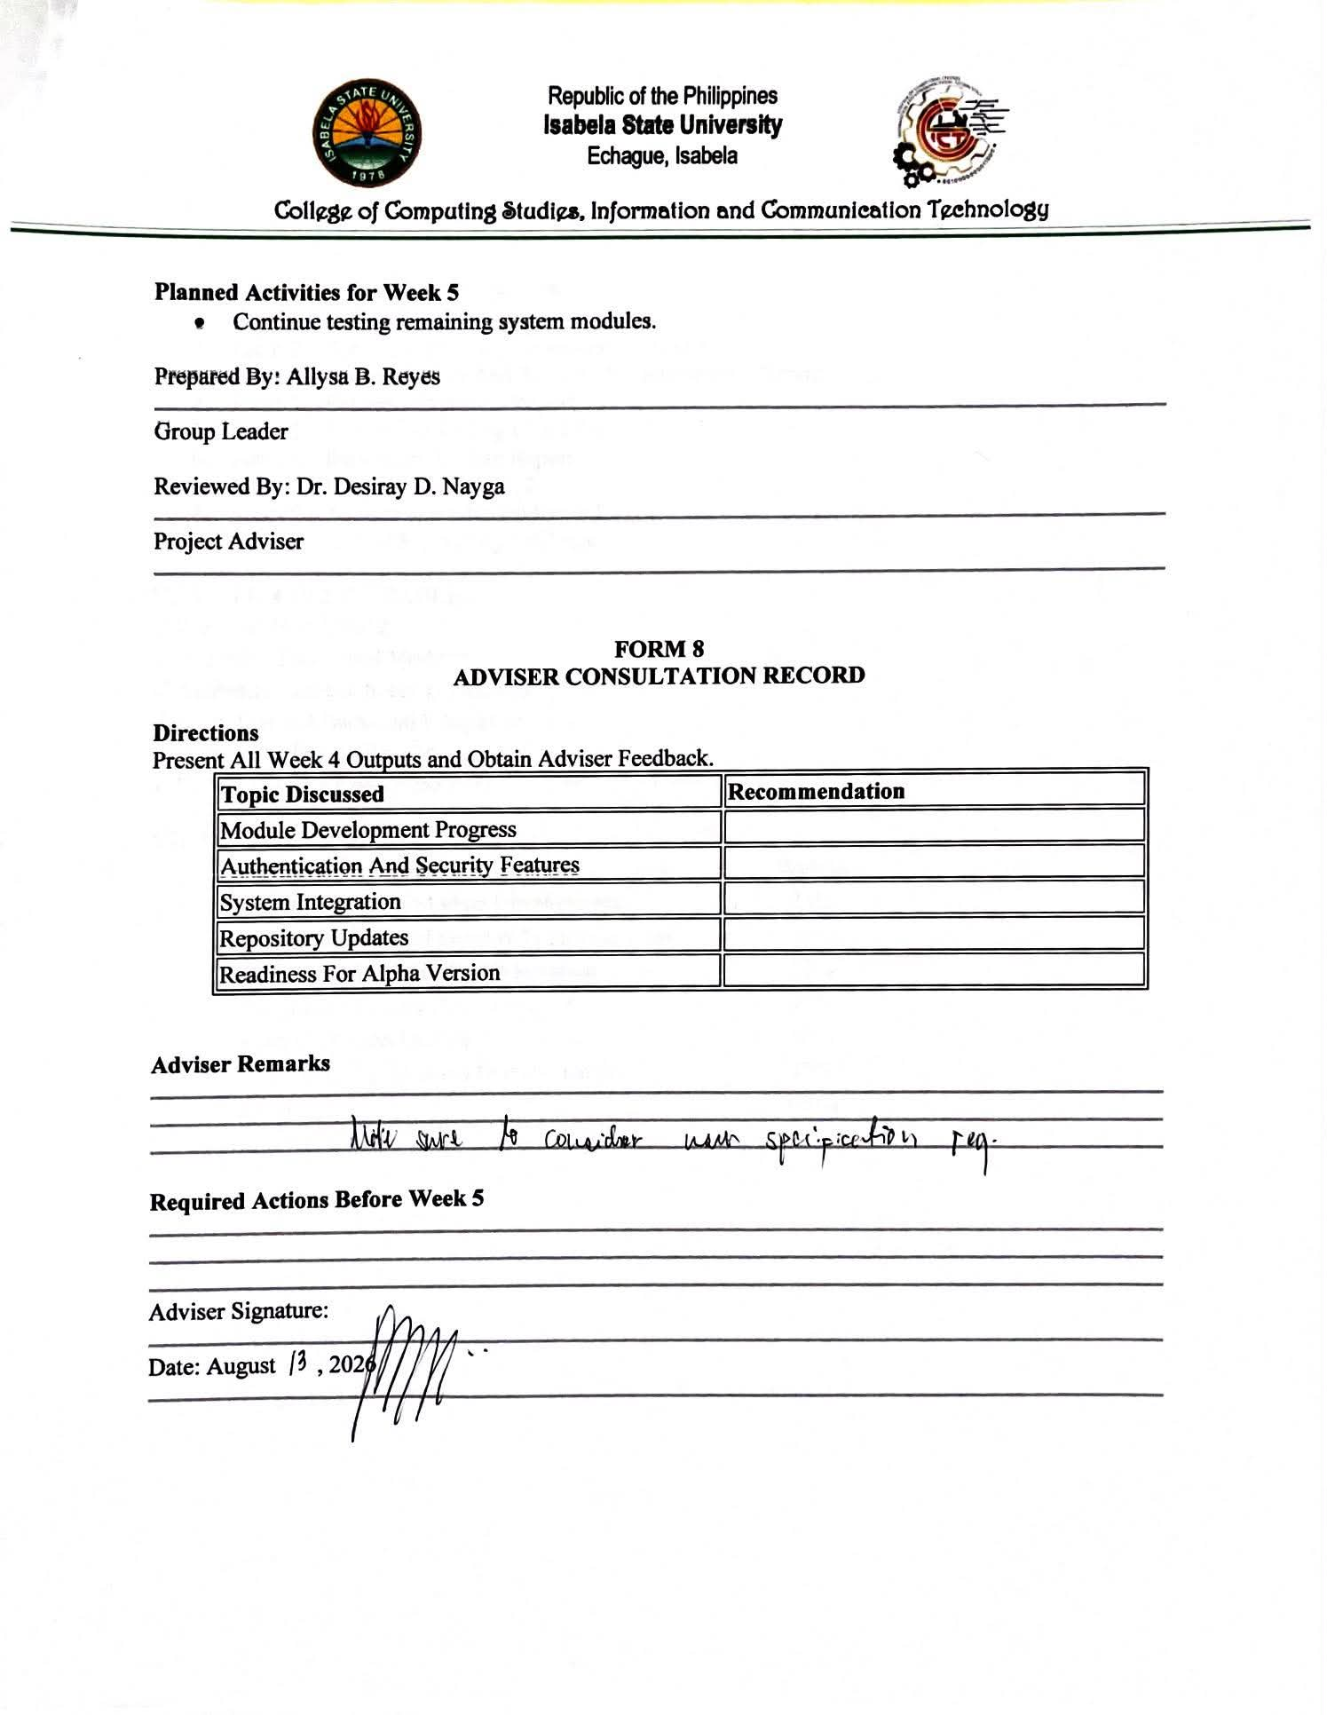
Planned Activities for Week 5
- Continue testing remaining system modules.

Prepared By: Allysa B. Reyes

Group Leader

Reviewed By: Dr. Desiray D. Nayga

Project Adviser

FORM 8
ADVISER CONSULTATION RECORD

Directions
Present All Week 4 Outputs and Obtain Adviser Feedback.
Topic Discussed | Recommendation
Module Development Progress
Authentication And Security Features
System Integration
Repository Updates
Readiness For Alpha Version

Adviser Remarks

Required Actions Before Week 5

Adviser Signature:

Date: August , 2026

V. REQUIRED WEEK 4 SUBMISSION
- Form 1 – Development Task Assignment
- Form 2 – Advanced Module Development Report
- Form 3 – Authentication And Security Implementation Report
- Form 4 – System Integration Report
- Form 5 – Integration Testing Checklist
- Form 6 – Repository Update Report
- Form 7 – Progress Report No. 2
- Form 8 – Adviser Consultation Record
- Screenshots And Supporting Evidence

VI. WEEK 4 DELIVERABLES
✓ Progress Report No. 2
✓ Integrated Functional Modules
✓ Authentication and Security Features
✓ Front-End and Back-End Integration
✓ Integration Testing Results
✓ Updated Source Code Repository

VII. PERFORMANCE RUBRIC
Criteria | Weight
Completeness Of Module Development | 25%
Authentication And Security Implementation | 20%
Front-End And Back-End Integration | 25%
Integration Testing Documentation | 10%
Progress Report Quality | 10%
Repository Updates and Documentation | 10%
Total | 100%

